
USER MANUAL
Carisk FCM
Published on: May 27, 2022



Prepared by
Technical Writing Team, Spiralogics, Inc.

Table of Contents
ABBREVIATIONS i
DEFINITIONS ii
1. Executive Summary 1
1.1 Purpose of Document 1
1.2 Identification 1
1.3 Scope 1
2. Design Overview 1
2.1 Background Information 1
2.2 Application Overview 1
3. Getting into the System 2
3.1 Sign In 2
3.2 Home Page 2
4. Cases 3
4.1 Add Cases 3
4.1.1 Add Case Information 4
4.1.2 Claimant 4
4.1.3 Employer 5
4.1.3 Account 6
4.1.4 Adjuster 7
4.1.5 Diagnosis 8
4.1.6 Medical Provider 9
4.1.7 Attorney 11
4.2 View Case 14
4.2.1 Edit Cases 17
4.2.1.1 Documents 18
4.2.1.2 Activity 21
4.2.1.3 Invoice 25
4.2.1.4 Report 26
4.2.2 Delete Case 28
5. Manage 29
5.1 Account 30
5.1.1 Add Account 30
5.1.2 View Account 32
5.1.2.1 Edit Account 33
5.1.2.2 Delete Account 35
5.2 Employee 36
5.2.1 Add Employee 36
5.2.2 View Employee 39
5.2.2.1 Edit Employee 40
5.2.2.2 Delete Employee 41
6. Invoice 42
6.1 Pending Invoice 42
6.1.1 Approve Invoices 43
6.1.2 Reject Invoices 44
6.2 Approved Invoices 45
7. Change Password 47
8. Sign Out 48

ABBREVIATIONS

CMS: Case Management Software
DOB: Date of Birth
DOC: Document
DOI: Date of Injury
DOR: Date of Referral
FCM: Field Case Manager
GB: GigaByte
GIF: Graphic Interchange Format
ICD: International Classification of Disease
JPEG: Joint Photographic Experts Group
JPG: Joint Photographic Expert Group
LTD: Long Term Disability
PDF: Portable Document Format
PNG: Portable Graphic Formats
PPT: PowerPoint Presentation
PPTX: PowerPoint Open XML
SSN: Social Security Number
STD: Short Term Disability
TCM: Telephonic Case Number
TIFF: Tagged Image File Format
TXT: Text
XLS: Microsoft Excel Spreadsheet
XLSX: Excel Microsoft Office Open XML Format Spreadsheet
ZIP: Zone Improvement Plan

DEFINITIONS

Case Manager: The case manager plays a vital role in the CMS project, who is responsible for managing a case after a case is created. CM ensures that the injured person receives proper medical care and continues to get an update of it via proper documentation process.
Claim No: It works as an insurance number for the injured patient. This number can be used to derive detailed information about the injured party.
FCM: The case manager travels to the medical place that took for a long-term care that follows an official Disability Guidelines.
TCM: The case manager is made responsible for caring for the patient via telephone. You can appoint a cost effective and early procedure of the case manager for the treatment of the patient.

1. Executive Summary

1.1 Purpose of Document
This document assists the admins or case managers of the CMS (Case Management System) to access, modify and update the health-related issue on the employee. It entails in-depth for the descriptive information related to the medical facilities & its cost provided to the Claimant.
1.2 Identification
Application URL | https://fcm.cariskpartners.com
OS | Windows
Version | 0.1
Browser | Google Chrome, Microsoft Edge, Mozilla Firefox, Brave

2. Design Overview

2.1 Application Overview
Carisk FCM is a web-based application for case management that provides proper streamlined management of a claim process. It is a lite version of a case management system that manages claims intake, process reports, log activities, and invoices. This is designed for small organizations with limited features for handling/processing claims.

3. Getting into the System

3.1 Sign In

You need to enter a valid username and password and click on the Login button to access the application.

Figure 1: Sign in Page

3.2 Home Page
Once you sign in, the home page is as follows.
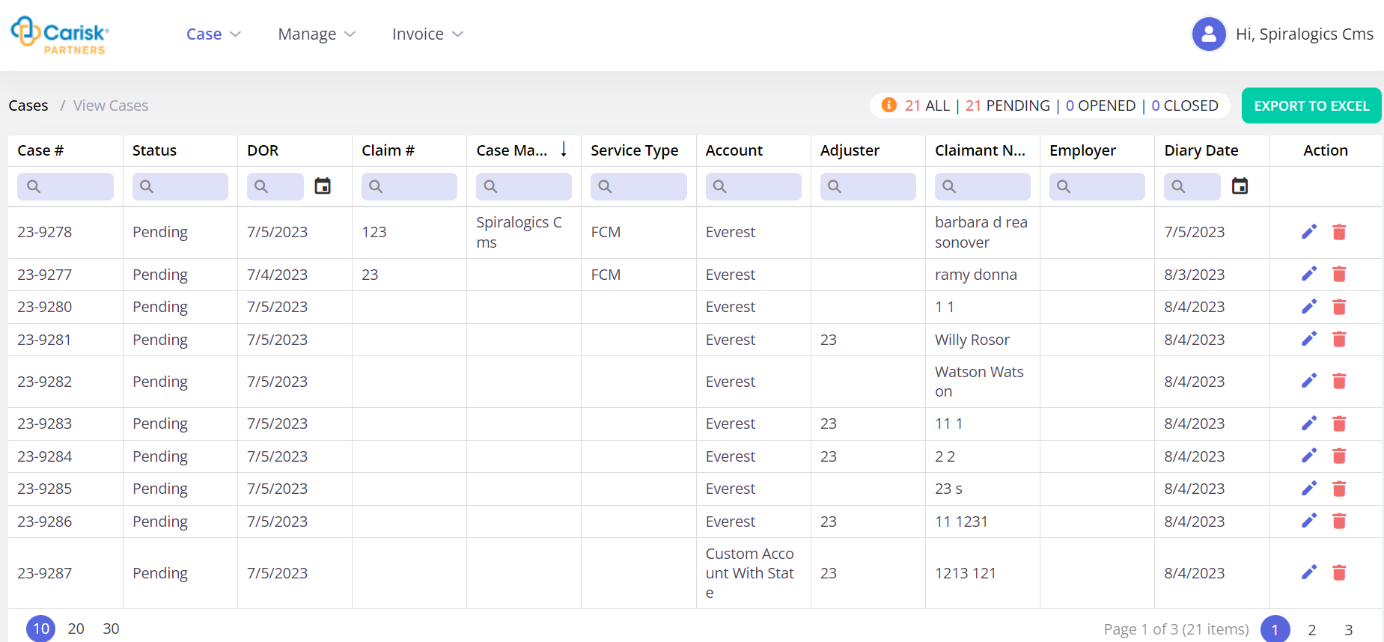
Figure 2: Home Page
The home page displays the View Cases grid which displays the following case information:
- Cases #
- Status
- DOB
- Claim #
- Case Manager
- Service Type
- Account
- Adjuster
- Claimant Name
- Employer
- Diary Date
In the above grid, action column allows you to edit or delete options for each row of case which is further explained in section 3.2.

4. Cases
To add new cases to the list, you can click on the cases link for the specification of the injured person. You can access cases to add or view from menu as highlighted below.
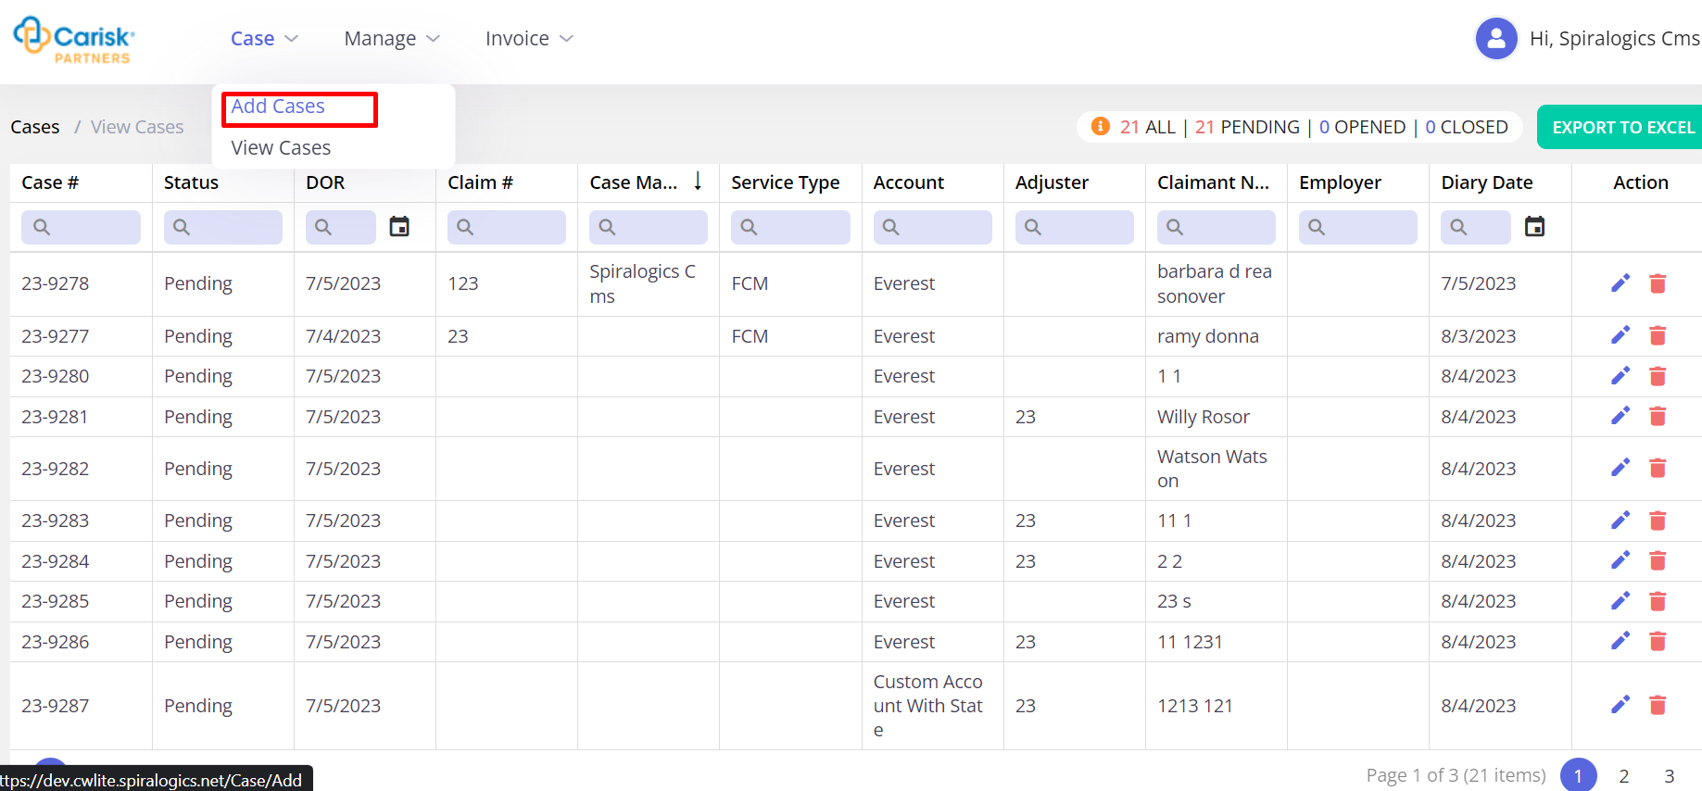
Figure 3: Cases Menu

4.1 Add Cases
To add cases, you can click on Add Cases under Cases menu, which opens following page:
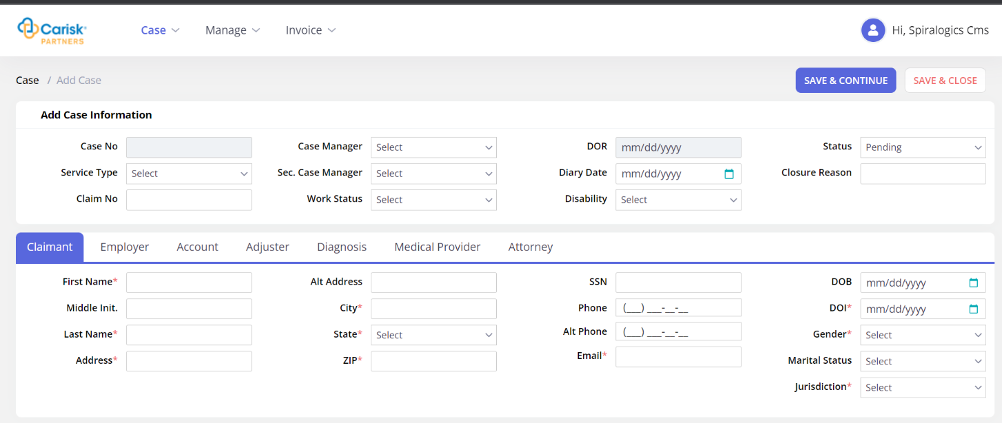
Figure 4: Add Case Page

4.1.1 Add Case Information
You can add case information in the first section of the page as highlighted below.

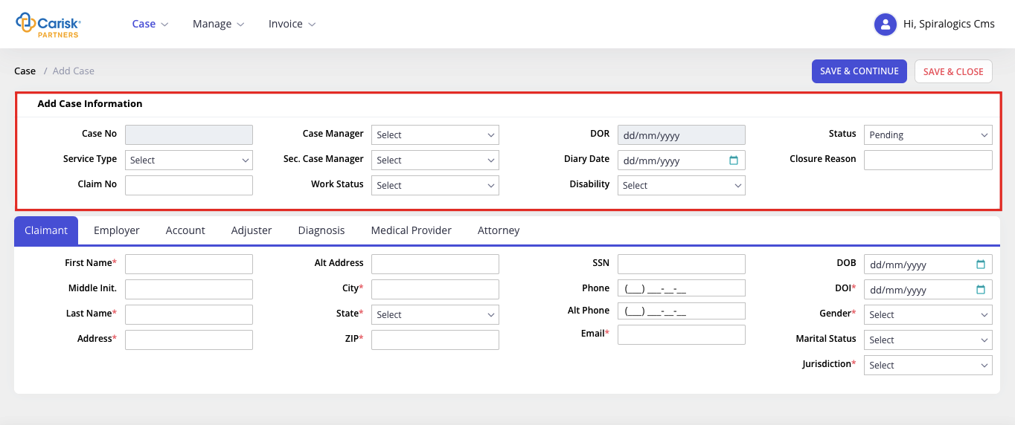
Figure 5: Add Case Info
Case No, DOR and Diary Dates are assigned by the application when complete case information is entered and any one of the save buttons either ‘Save & Continue’ or ‘Save & Close’ can be clicked.

4.1.2 Claimant
The claimant is an injured worker whose case will be recorded here. All the associated information will be added to the application. All the progress and treatments will be documented with the proper reports.
You need to add claimant information in add case page under Claimant tab as shown below.
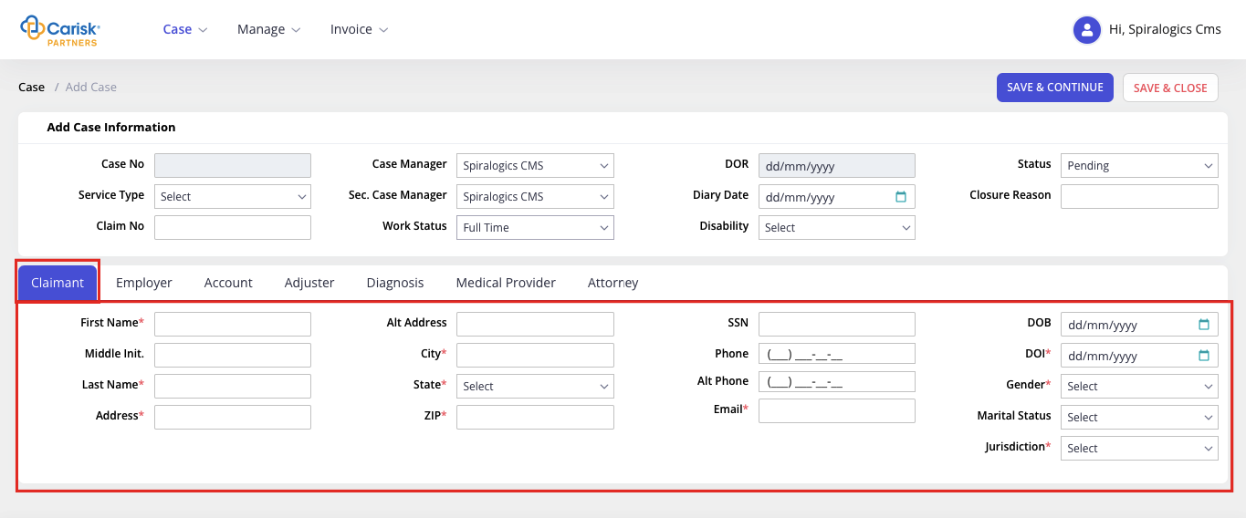
Figure 6: Claimant Tab
In the claimant tab, the following are required fields:
- First Name
- Last Name
- Address
- City
- State
- Zip
- DOI
- Gender
- Jurisdiction

4.1.3 Employer
Information of the claimant’s organization for whom they are working will be added here.
You can enter employer information under Employer tab as shown below.
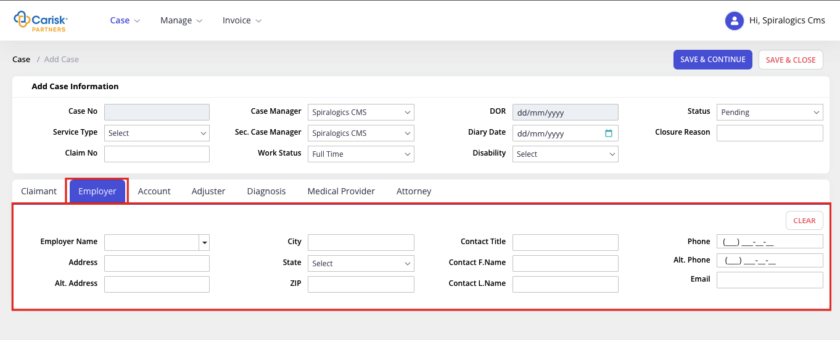
Figure 7: Employer Tab
In employer tab, when an employer name is selected from the dropdown, it auto-populates respective employer’s information in all the other fields.
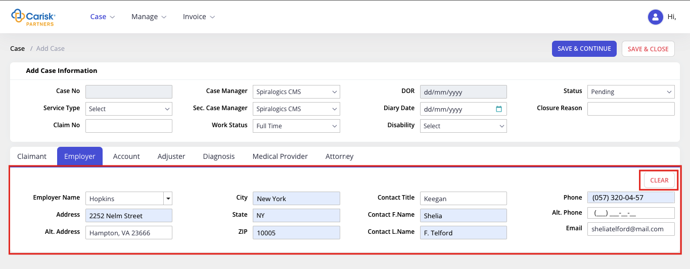
Figure 8: Auto-fill of Employer Tab
You can click on the CLEAR button to remove all the information entered in employer tab fields.
You can also add a new employer, by manually entering employer details in each field, and clicking on any one of the save buttons on top will create a new employer.

4.1.3 Account
You can enter the account information under Account tab as shown below:
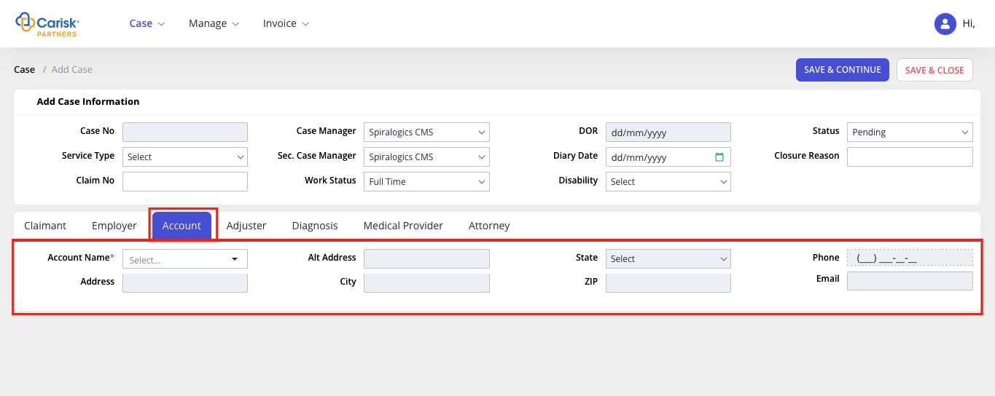
Figure 9: Account Tab
In account tab, Account Name is a required field. You can select account name from the dropdown which auto-populates respective account’s information in all the other fields. The accounts added from the manage module will be listed in the account name dropdown field.
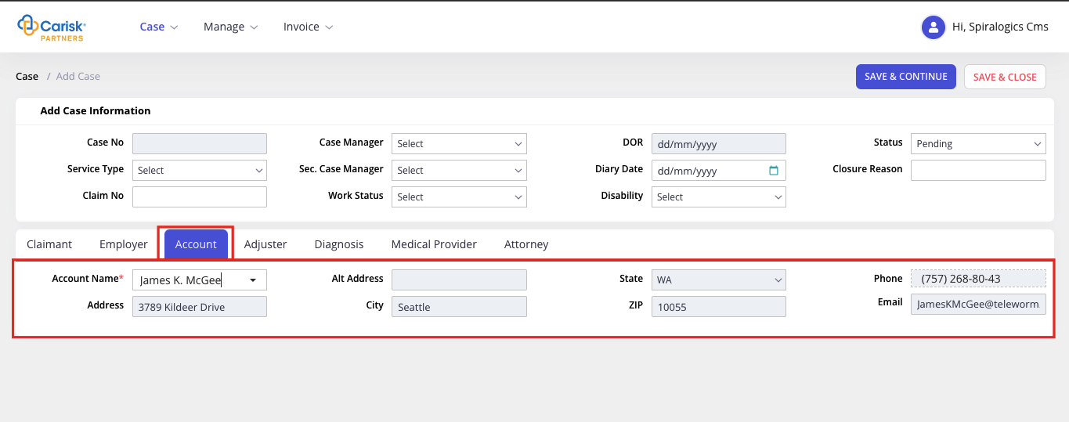
Figure 10: Account Name list

4.1.4 Adjuster
You can add adjuster information under Adjuster tab. The adjuster tab is as shown below:
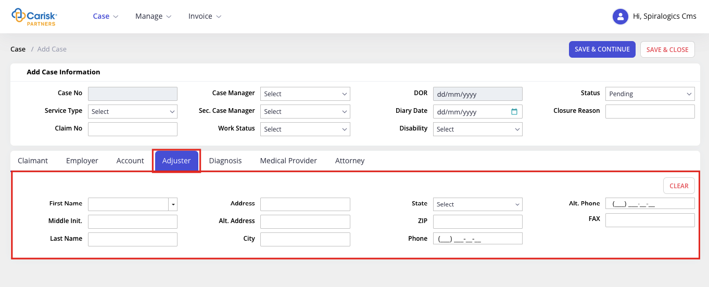
Figure 11: Adjuster Tab
When first name is selected from the dropdown, it auto-populates respective adjuster’s information in all the other fields.
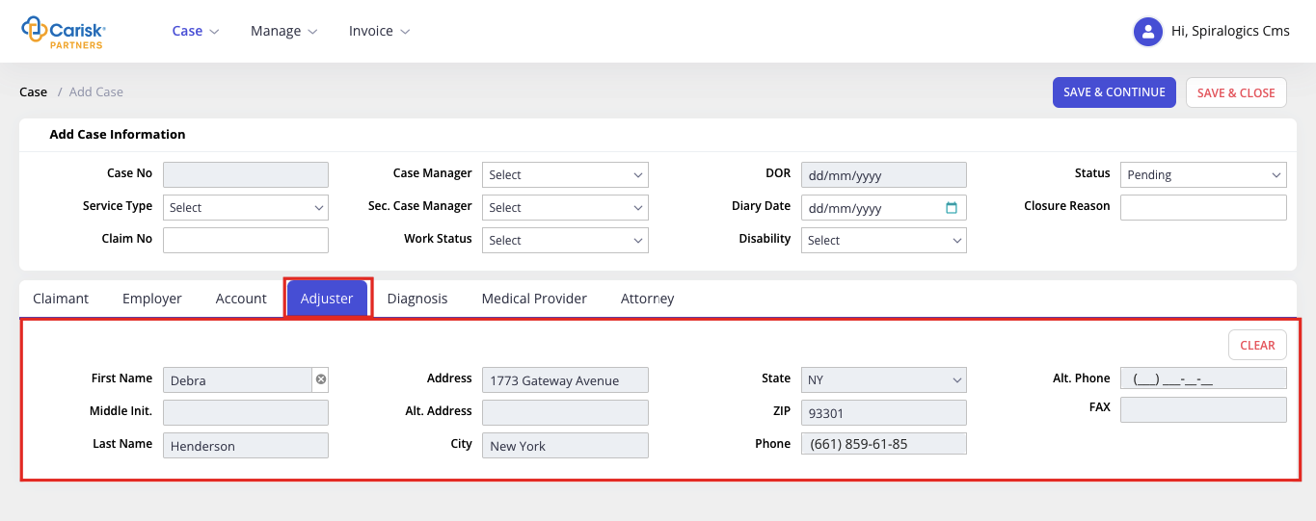
Figure 12: First Name Option
Or, to add a new adjuster, you can enter the adjuster details in each field, and clicking on any one of the save buttons on top will create a new adjuster.
You can also clear the entire field by clicking on the CLEAR button.

4.1.5 Diagnosis
You can enter the injury/disease diagnosed during the medical treatment under Diagnosis tab. Medical illness is enlisted in ICD which are categorized into different operational codes that can be selected from the dropdown.
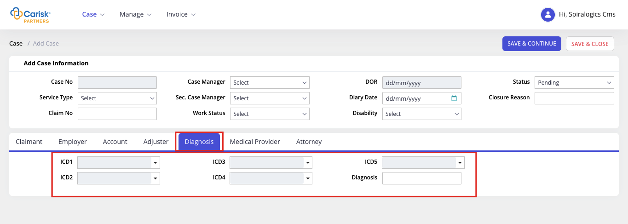
Figure 13: Diagnosis Tab

4.1.6 Medical Provider
An individual health professional or a health facility organization licensed to provide health care diagnosis and treatment services including medication, surgery and medical devices.
You can enter the details under Medical Provider tab as shown below:
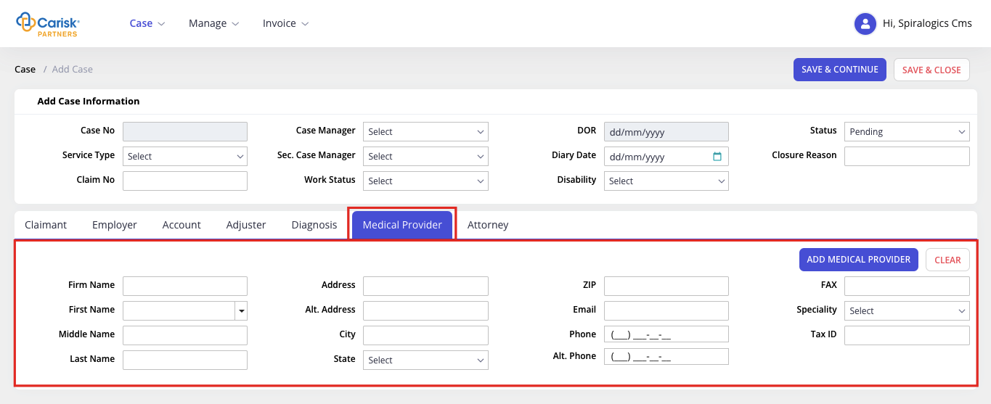
Figure 14: Medical Provider Tab
In this tab, you can select the first name from the dropdown, which auto-populates respective provider’s information in all the other fields.
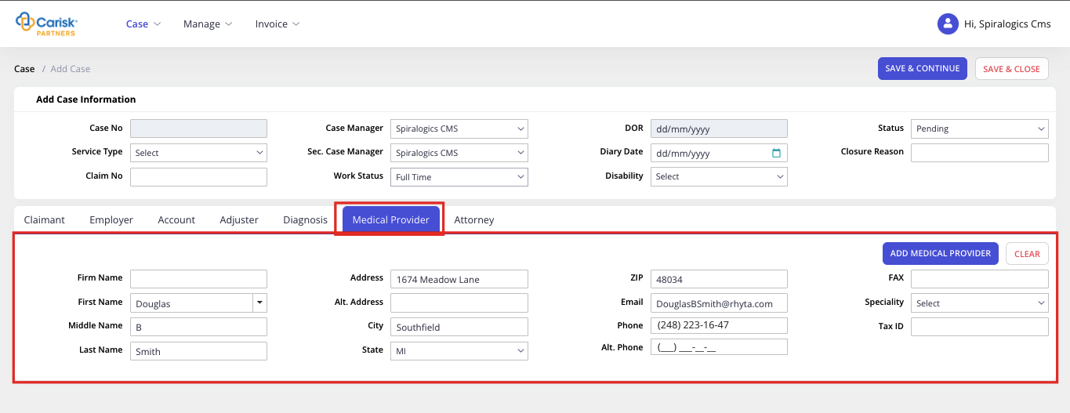
Figure 15: Medical Provider First Name
You can add a new medical provider by clicking on ADD MEDICAL PROVIDER button as highlighted below.
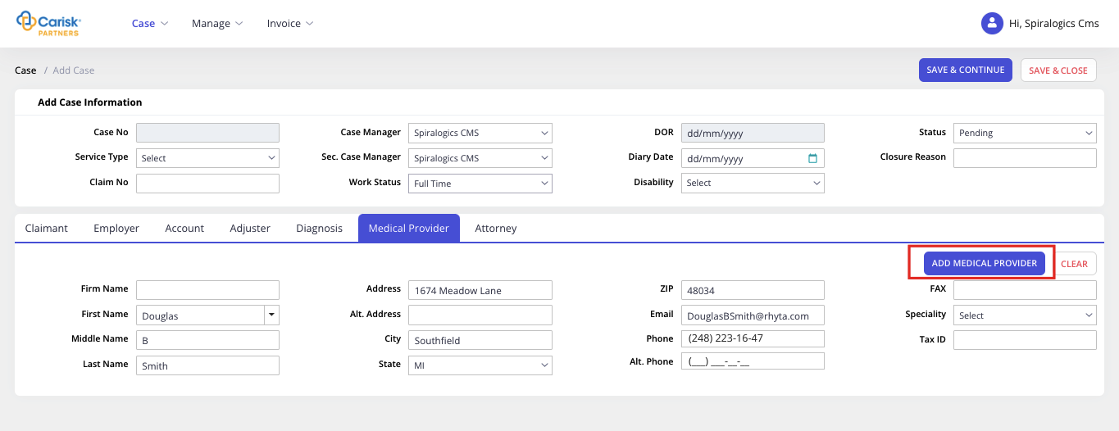
Figure 16: Add Medical Provider
On click, it further expands the section to add provider details as shown below:
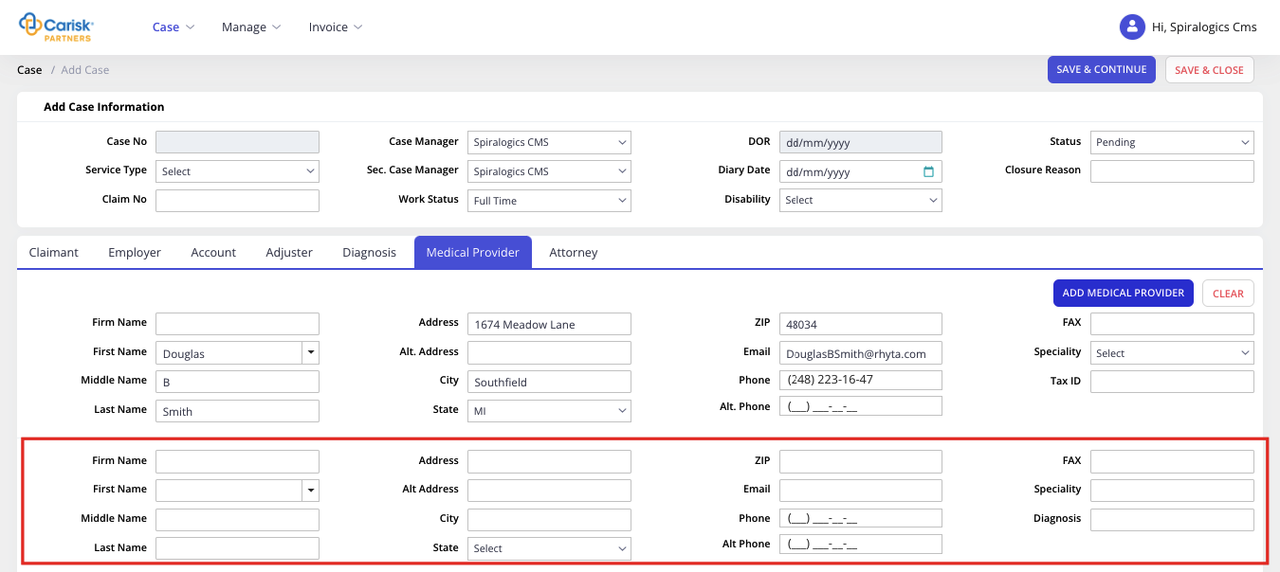
Figure 17: Multi-Medical Provider

4.1.7 Attorney
Attorney individuals with a background in the medical billing industry, who work with consumers to lower medical costs.
You can enter the claimant and defense attorney information under Attorney tab as shown below:
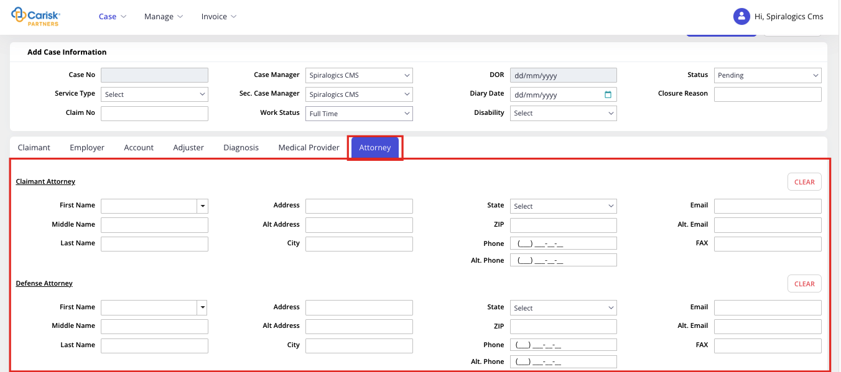
Figure 18: Attorney
This tab first provides Claimant Attorney section followed by Defense Attorney section.
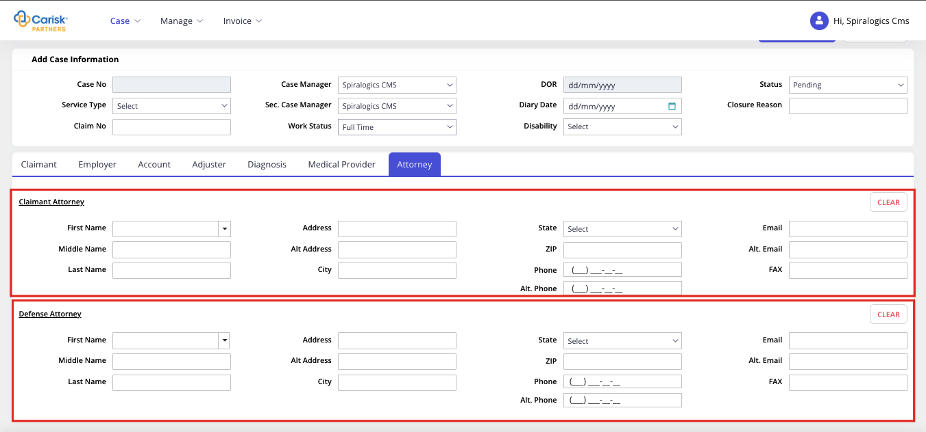
Figure 19: Claimant & Defense Attorney
In both sections, when you select first name, it auto-populates respective attorney’s information in the remaining fields.
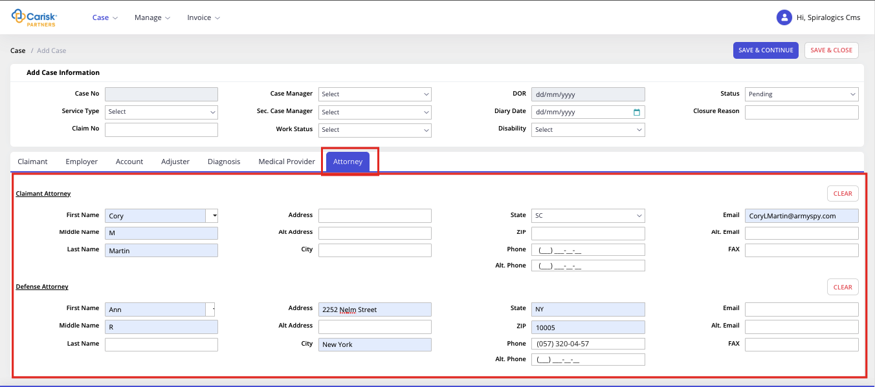
Figure 20: Auto-fill Attorney fields
Or, you can add a new claimant or defense attorney, by manually entering the attorney details in each field, and clicking on any one of the save buttons on top will create a new attorney.
Similarly, in both the sections, you can click on CLEAR button to remove the information from fields.
Once all the information is entered, you can click on Save & Continue button which creates a new case and allows you to continue adding further information on the same page.
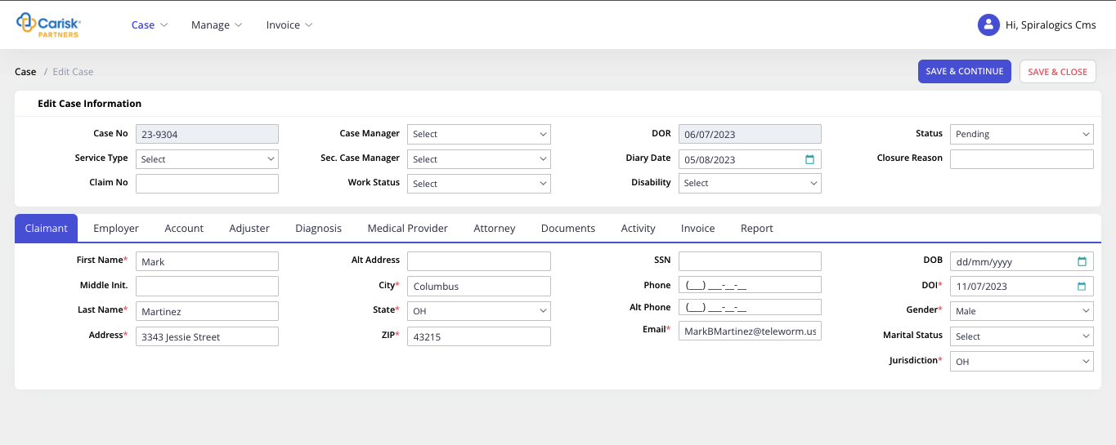
Figure 21: Save & Continue
Or, you can click on Save & Close after entering all the required information, which creates a new case and the add page is closed and re-directs to View Cases page.
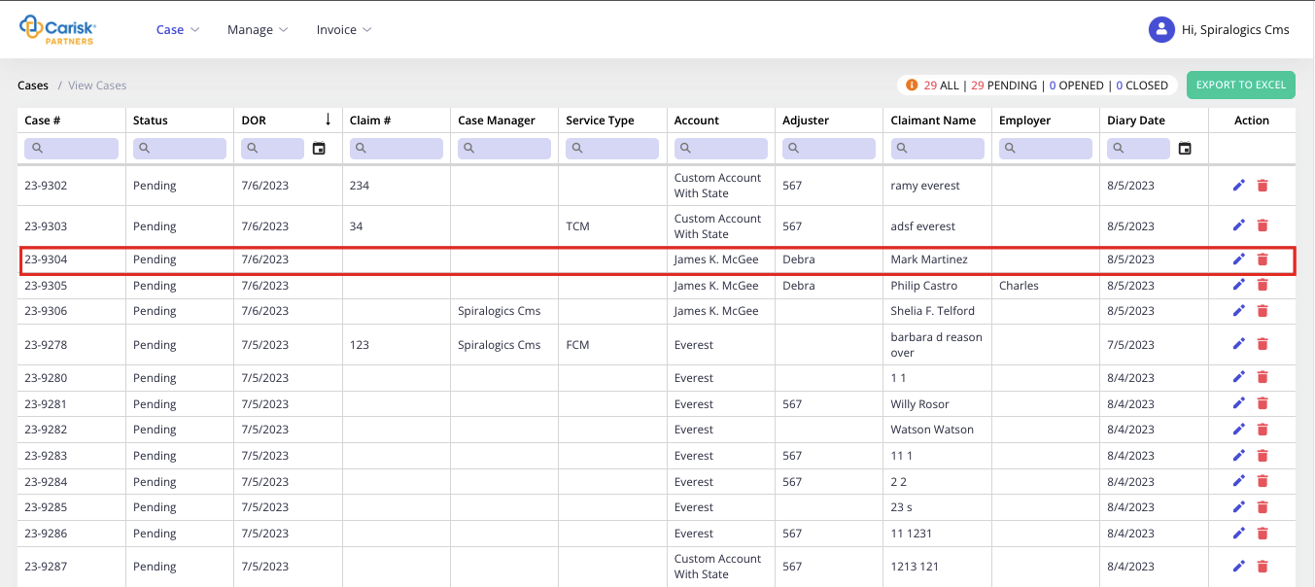
Figure 22: View Case
If all the required fields are not entered, and any one of the save button is clicked then error notification is shown highlighting all the required fields.
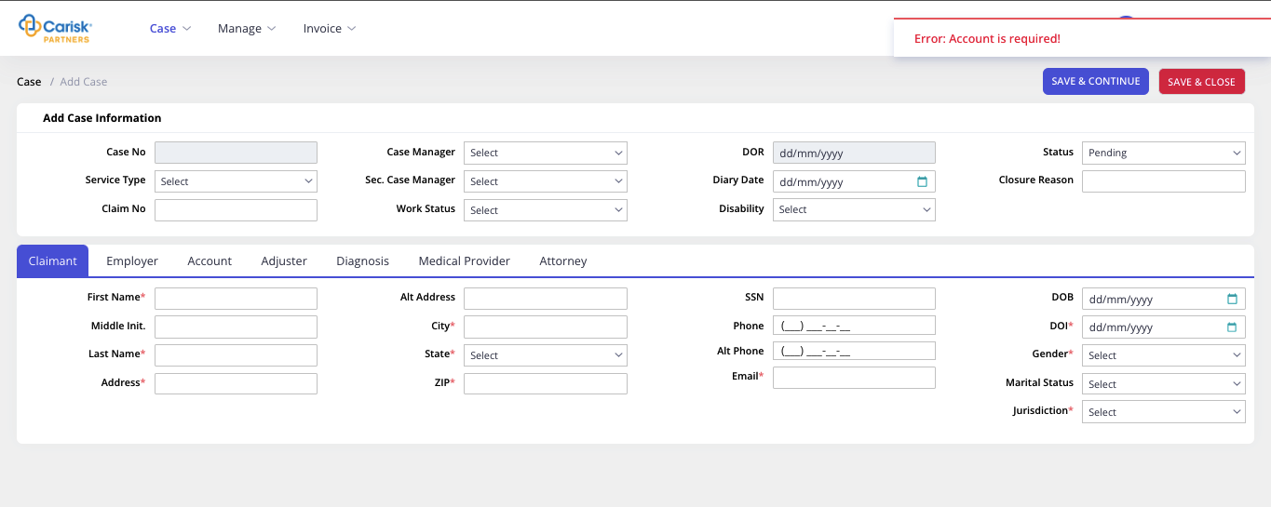
Figure 23: Error while adding Case

4.2 View Case
You can view the list of existing cases in the application, by selecting View Cases under Cases menu as highlighted below:
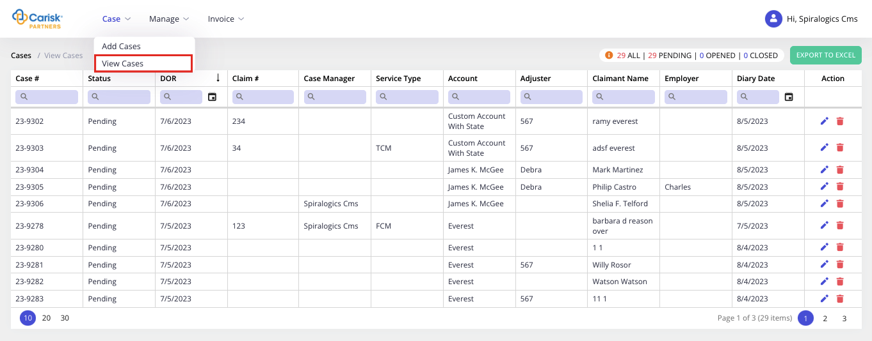
Figure 24: View Case List
Or, view cases grid is also accessible from the home page.
In this view cases page, on top right provides count of ALL, PENDING, OPENED and CLOSED cases.
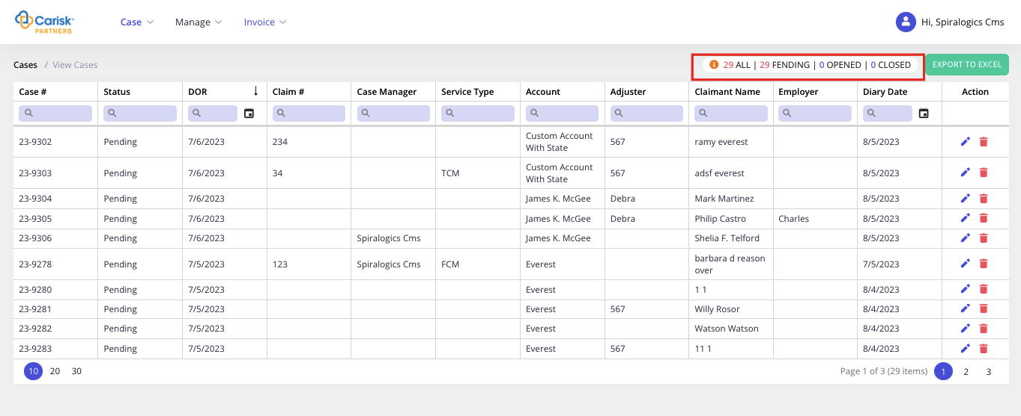
Figure 25: Cases Status
You can also click on the export button as highlighted below to export the view cases grid.
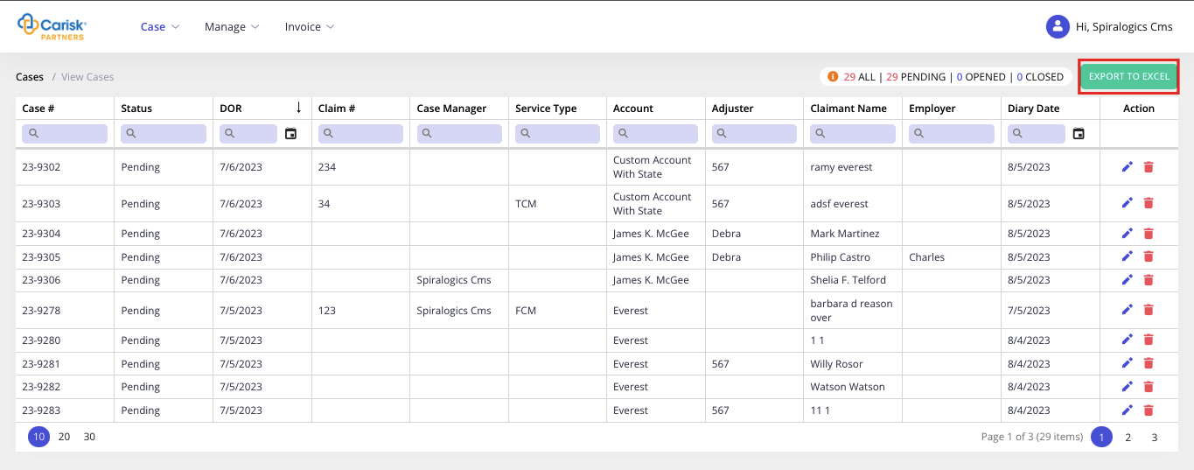
Figure 26: Export To Excel
Clicking on the export button downloads the excel file to your local device.

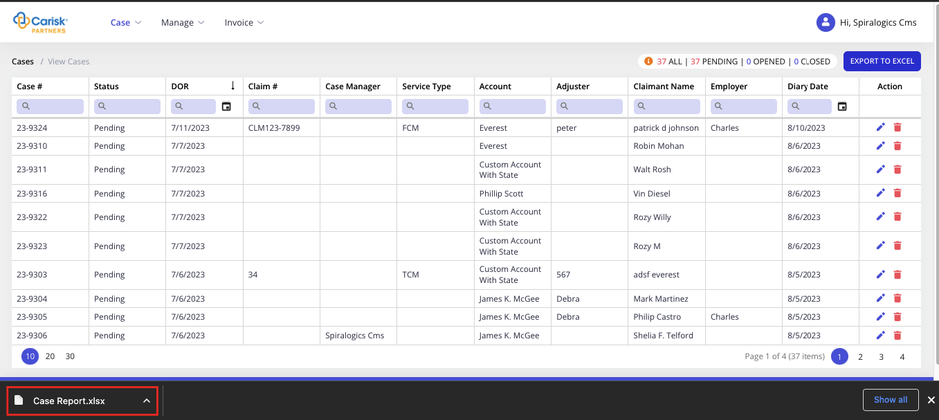
Figure 27: Case Report Download
In this grid, you can search in each column by entering value in search box as highlighted below.
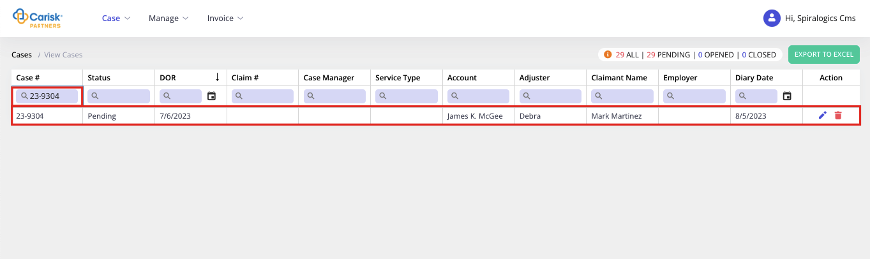
Figure 28: Search Result
Or, you can filter out using the following filter options available:
- Contains
- Does not contain
- Starts with
- End with
- Equals
- Does not equal
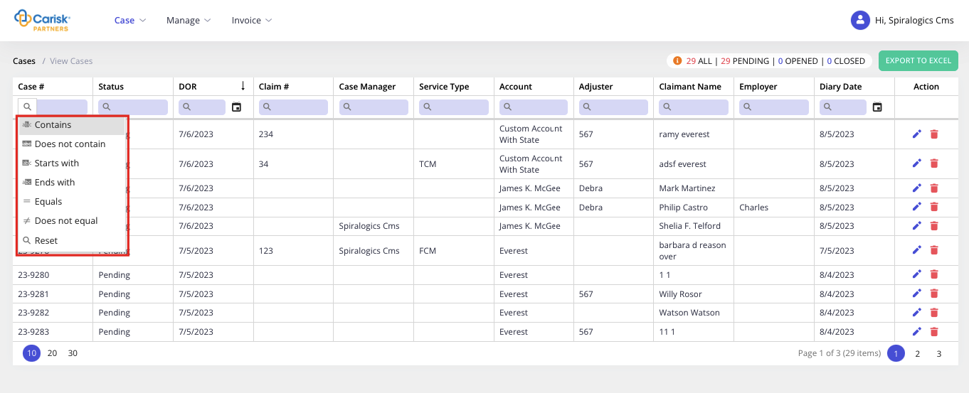
Figure 29: Filtering option
You can also sort data in each column either in ascending or descending order by using arrow right next to the column title.
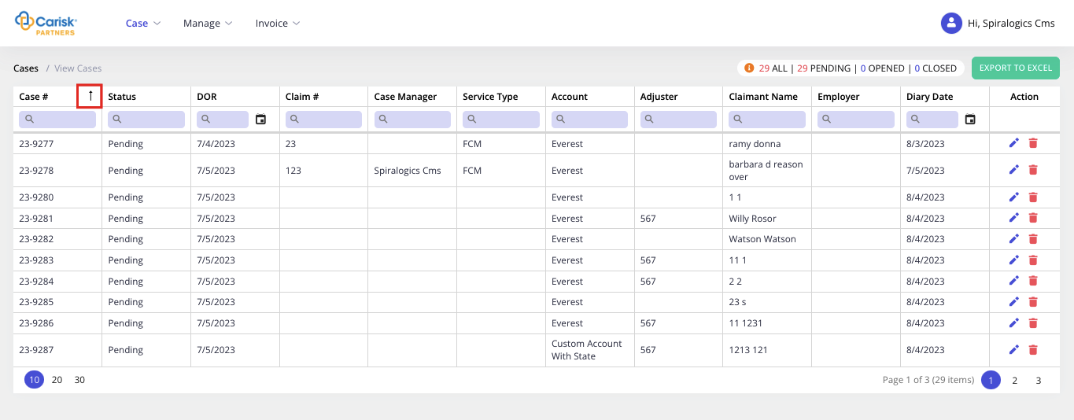
Figure 30: Sorting
NOTE: This search, filter and sort feature is also available in view grids of Accounts and Employee and all data grids through the application.

4.2.1 Edit Cases
You can edit the case by clicking on Edit button as highlighted below in action column for the acquired case.
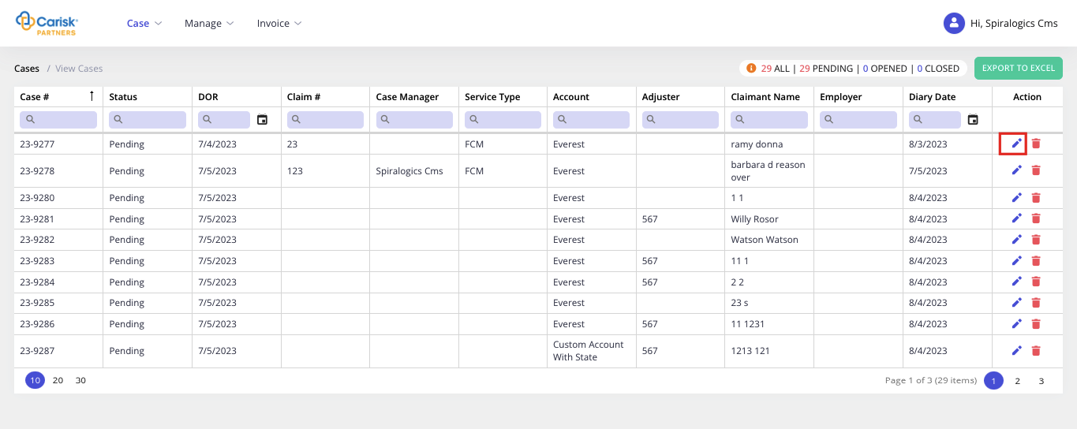
Figure 31: Edit Cases
On click, it opens the Edit Case page as shown below:
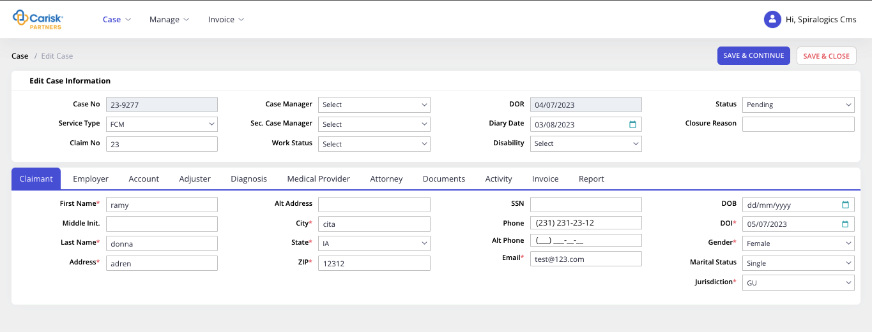
Figure 32: Edit Case Page
In edit case page, following four additional fields are available.

4.2.1.1 Documents
Under Documents tab, you can add relevant documents by clicking on ADD ATTACHMENTS button as highlighted below.
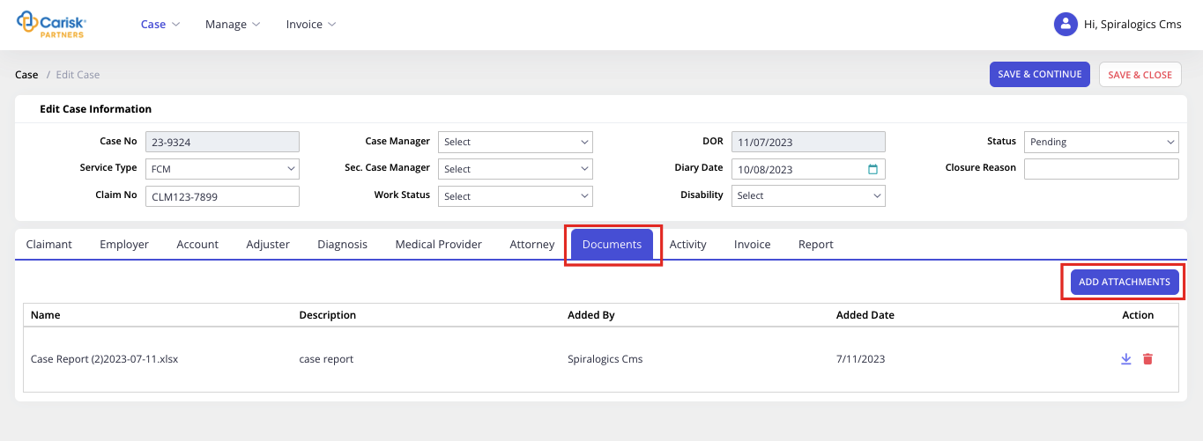
Figure 33: Document Tab
On click, it renders attachment popup to upload file as shown below.
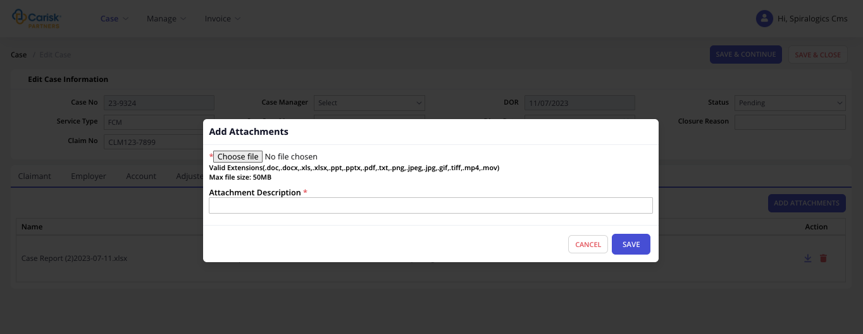
Figure 34: Attachment Documents
In this popup, File and Attachment Description are required fields.
You can attach files of maximum size 50MB, with following list of extensions:
- doc
- docx
- xls
- xlsx
- ppt
- pptx
- pdf
- txt
- png
- jpeg
- jpg
- gif
- tiff
- mp4
- mov
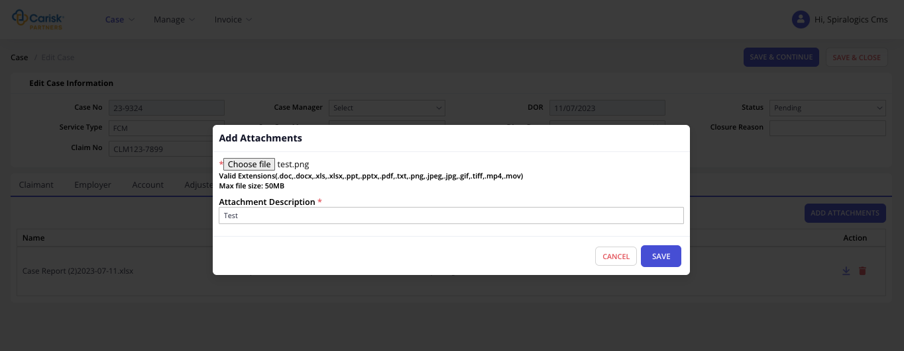
Figure 35: Add Extension File
Once file and description are entered, you can click on Save button to upload file attached.
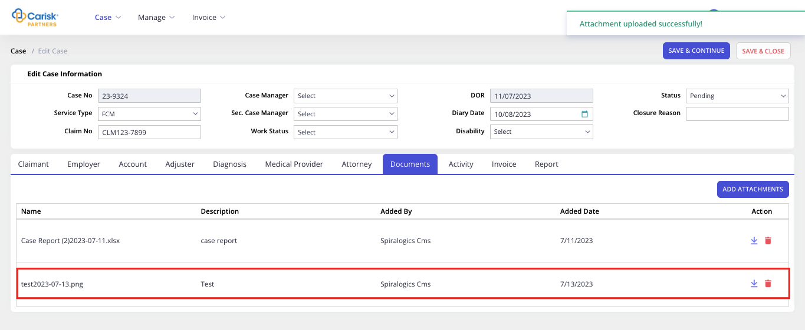
Figure 36: Saving Documents
You can perform the following two operations for attached files.
- Click on Download icon as highlighted below, to download attached file in your local device.
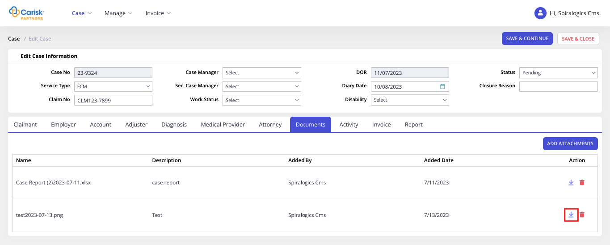
Figure 37: Download Documents
- Delete the attached file by clicking on Delete button.
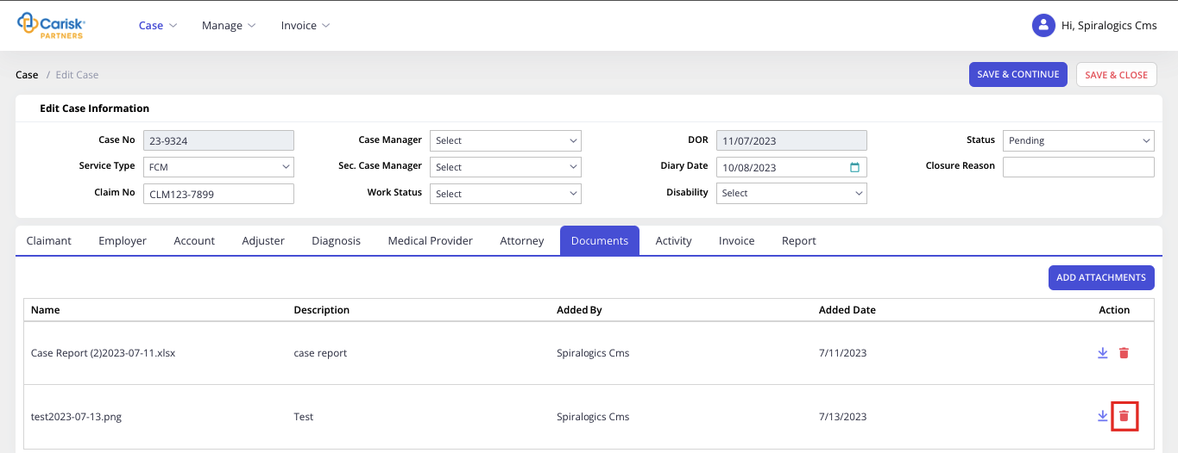
Figure 38: Delete Documents

4.2.1.2 Activity
You can add activity by clicking on + icon as highlighted below which add a single row of activity.
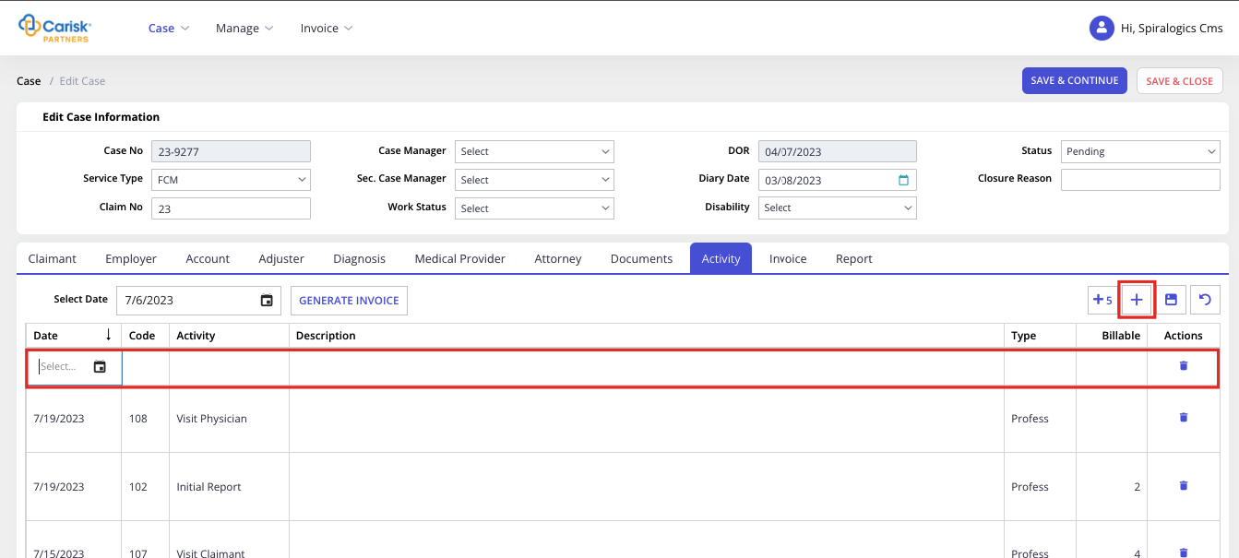
Figure 39: Activity Tab
You can also add 5 rows of activity at once by clicking on +5 button highlighted below:
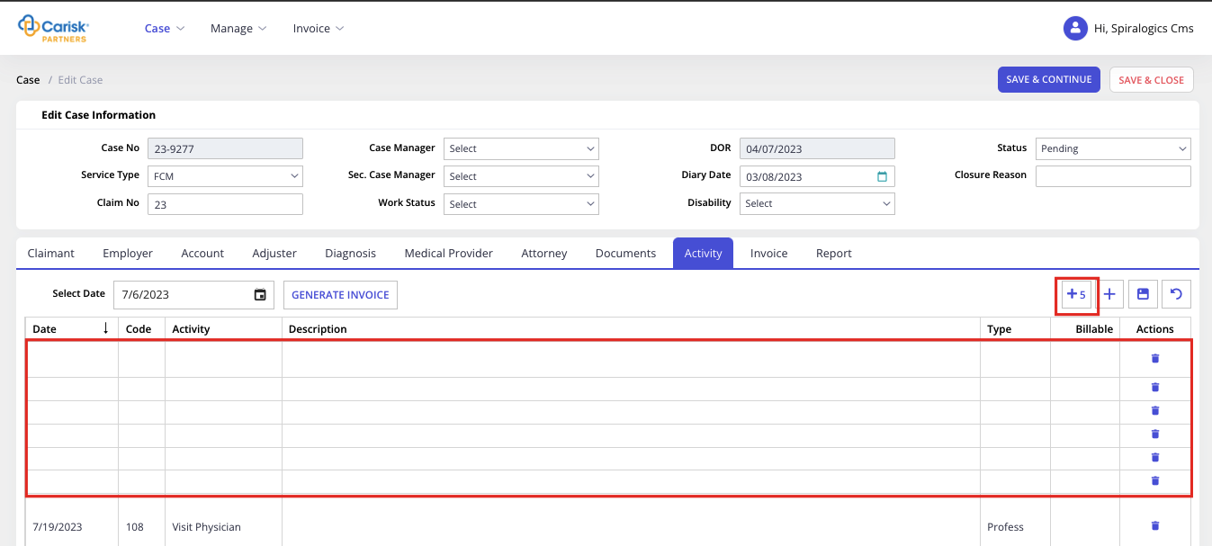
Figure 40: Inserted 5 rows at once
You need to click on each column to add information in the row. When Activity is selected from the dropdown then it populates information in Code and Type column.

Figure 41: Adding Code to Activity
After adding all activity details, you can click on Save icon as highlighted below to save entered activity.
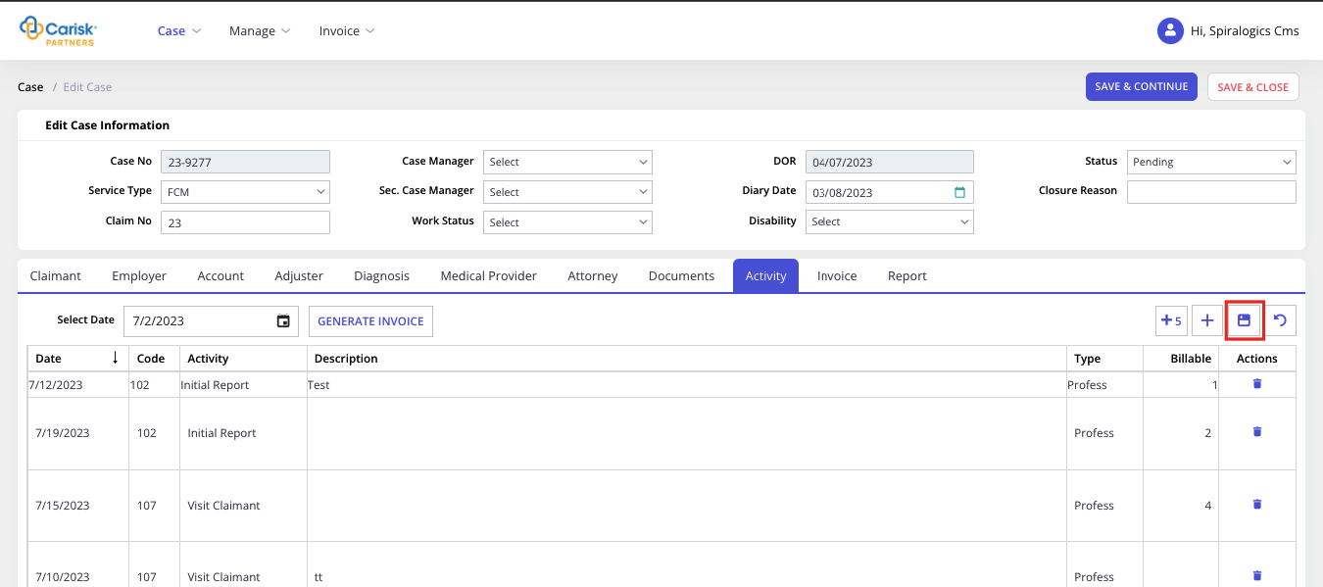
Figure 42: Saving Activity
You can clear information that has not been saved by clicking on Rewind icon as shown below:
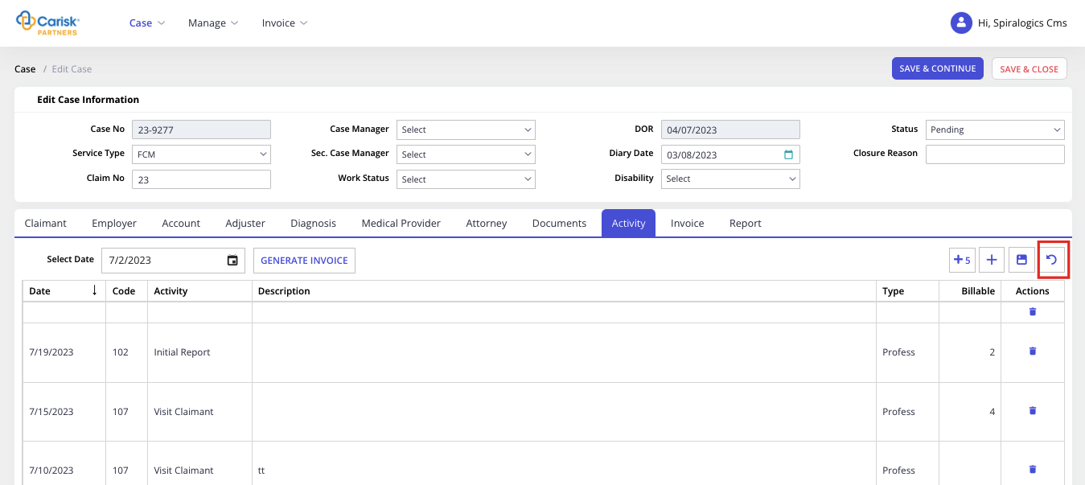
Figure 43: Rewind Activity
You can also delete the activity row by clicking on Delete icon as highlighted below:
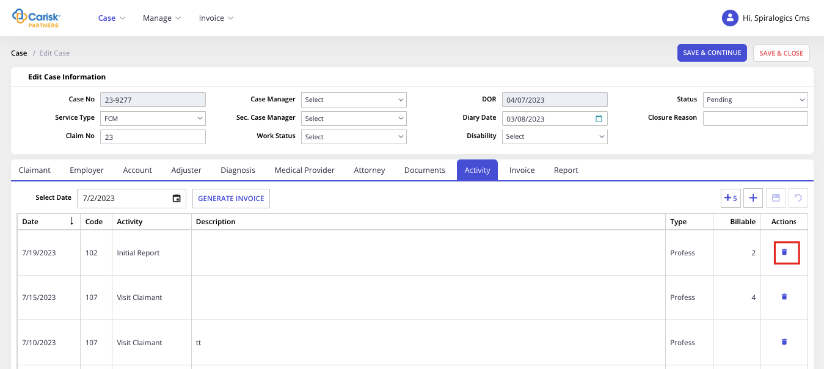
Figure 44: Delete Activity
Once activities are added, you can generate invoices till current date by clicking on the Generate Invoices button.
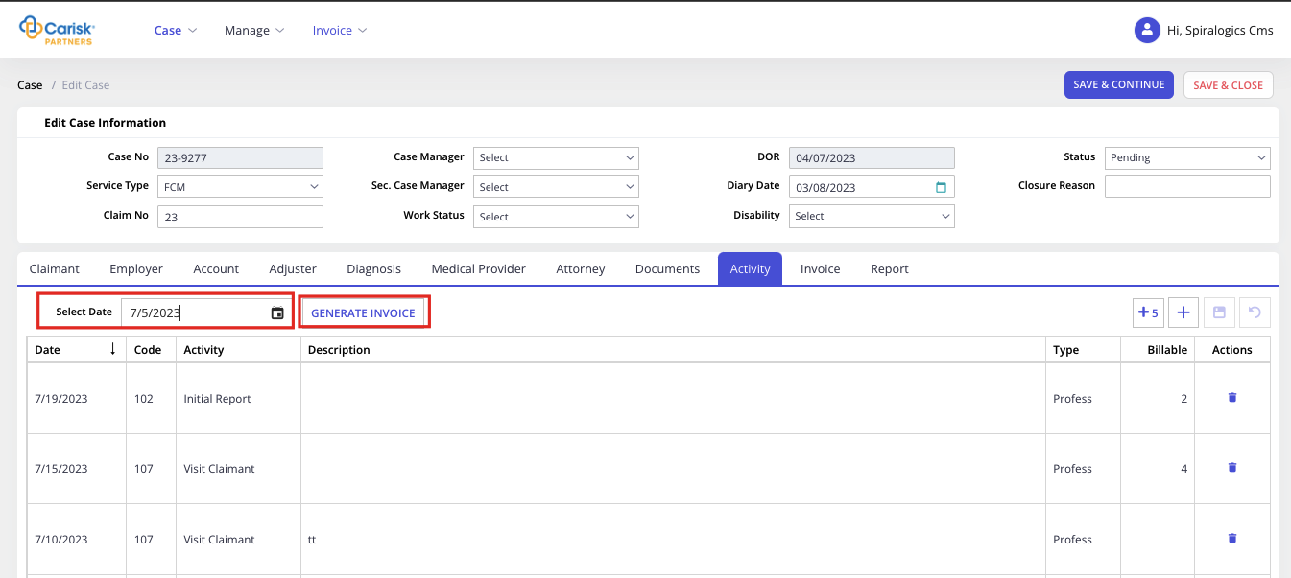
Figure 45: Generate Invoice
You cannot generate an invoice if there already exists a pending invoice for the respective case.
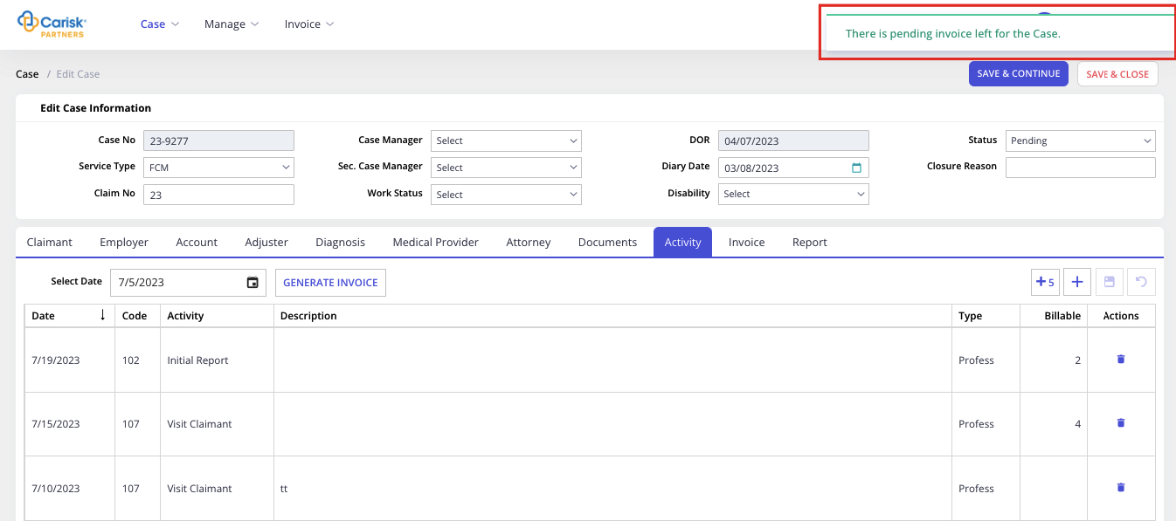
Figure 46: Pending Invoices
Otherwise, the invoice is generated and is listed under Invoices tabs as well as Pending Invoices list accessible from manage menu.

4.2.1.3 Invoice
Under this tab, you view the list of invoices created for the case and whose status is pending or approved.
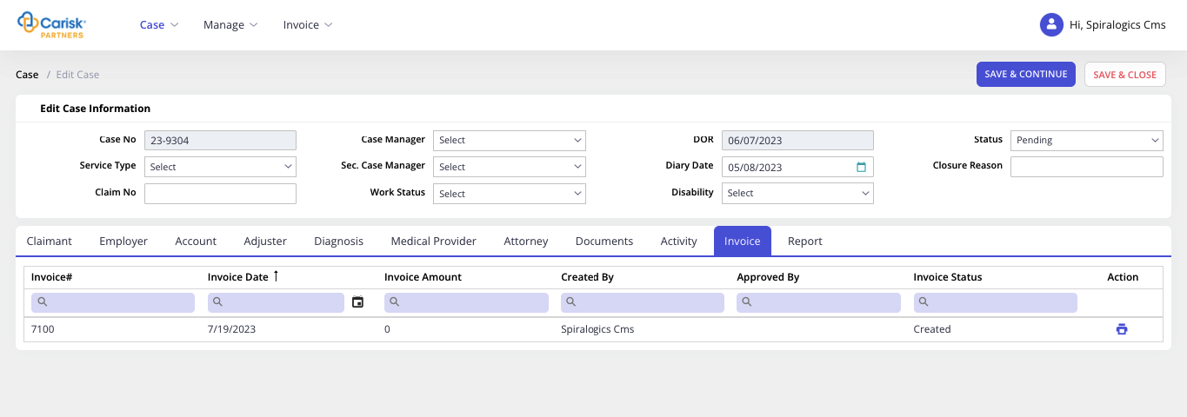
Figure 47: Invoice Status

4.2.1.4 Report
Under Report tab, you can download the following three types of report templates. Each report template is automatically downloaded to your local device.
- Initial Reports: You can click on ADD INITIAL REPORTS button to add respective report in the grid.
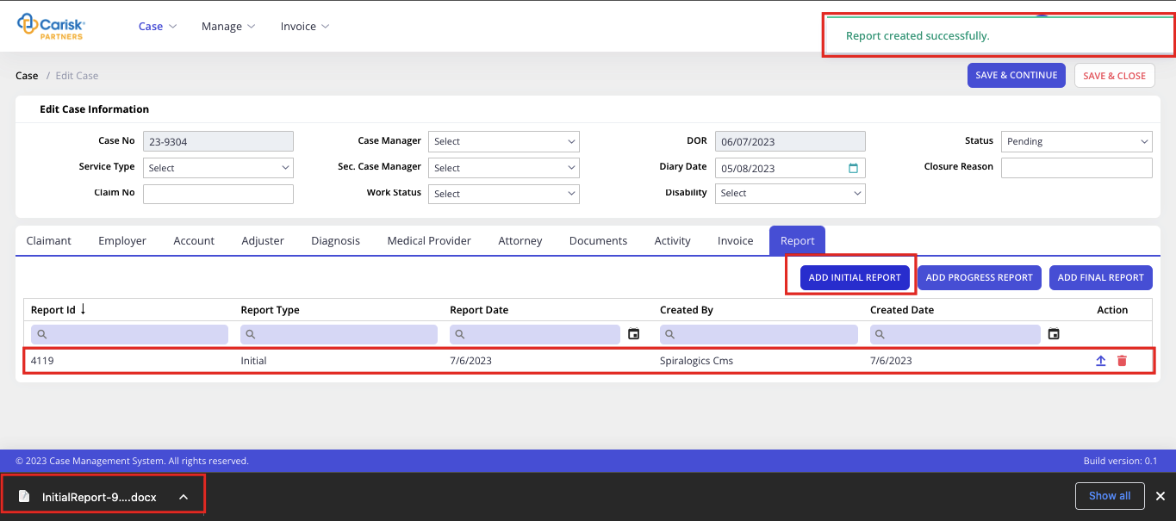
Figure 48: Creating Reports
- Progress Reports: You can click on ADD PROGRESS REPORTS button to add respective report in grid.
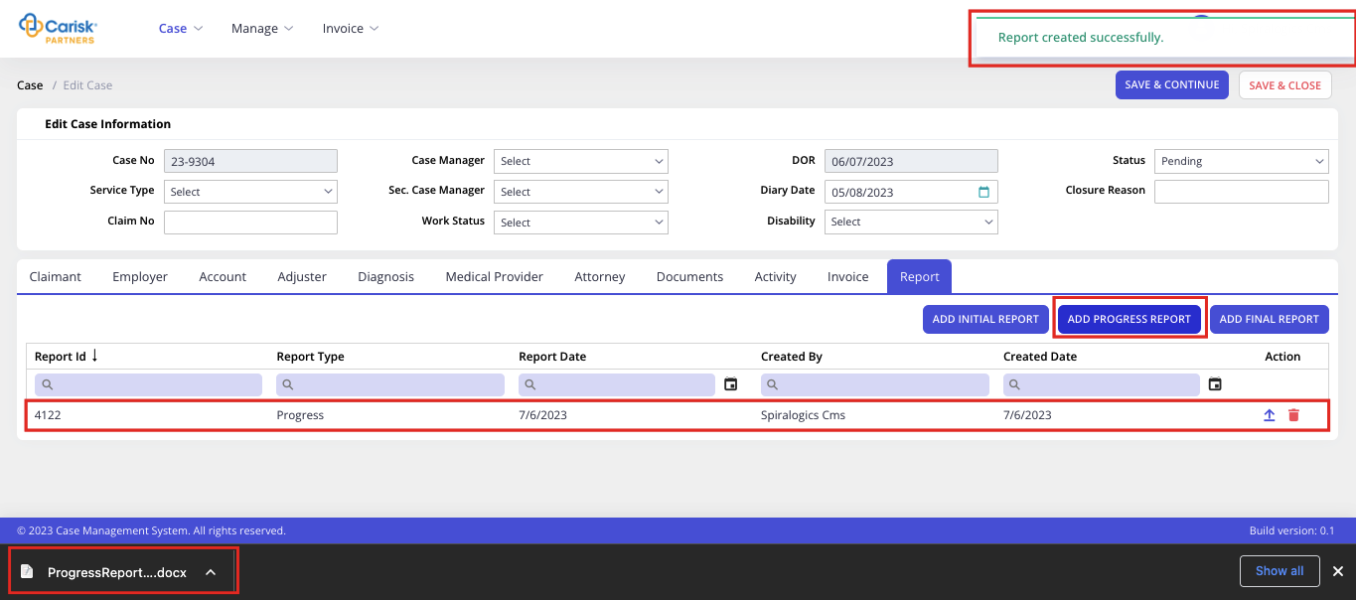
Figure 49: Progress Report
- Final Reports: You can click on ADD FINAL REPORTS button to add respective report in the grid.
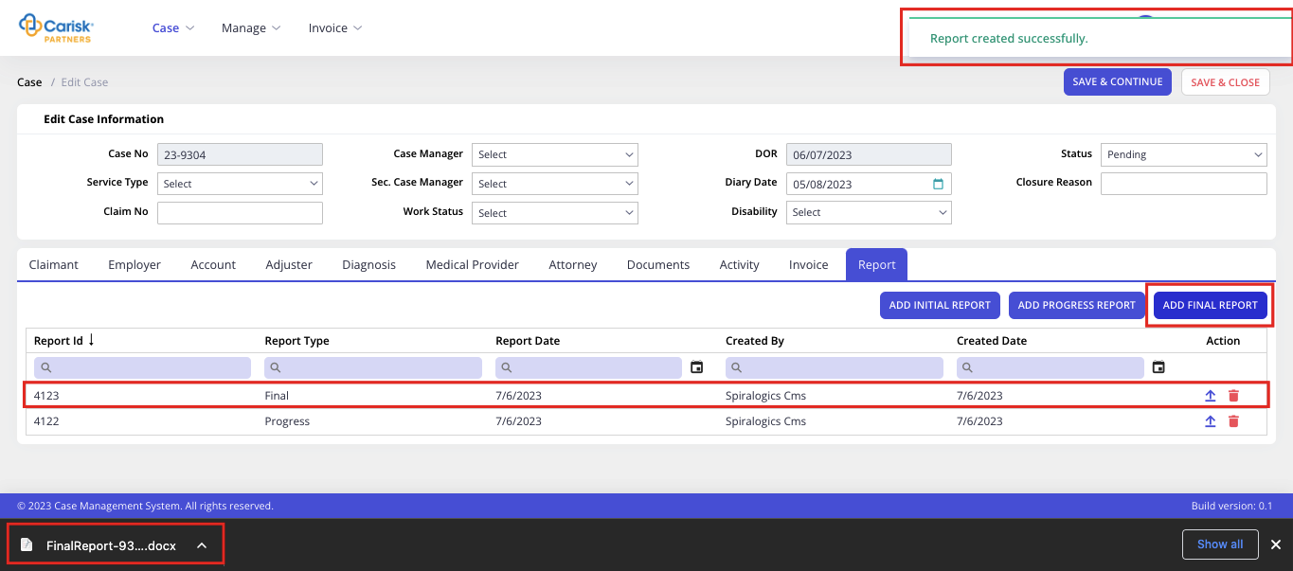
Figure 50: Final Reports
You can edit the desired report type template and upload it in respective row by clicking on Upload button as highlighted below:
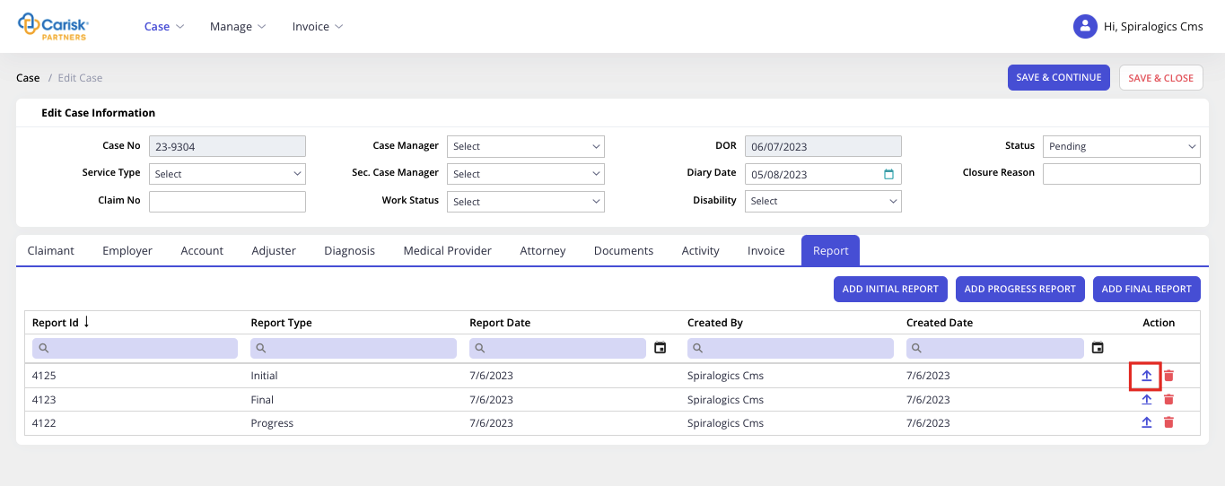
Figure 51: Upload Report
You can delete the report by clicking on Delete button of the required report row, which renders following confirmation popup.
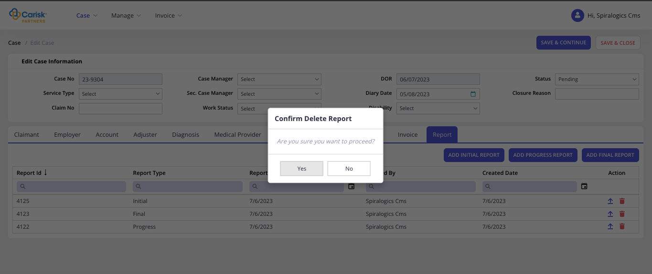
Figure 52: Delete Report
Click on Yes button to delete report or click on No button to abort delete operation.
After all the required information is edited, you can click on any one of the save button to update case details.

4.2.2 Delete Case
To delete case, you can click on Delete button as highlighted below in action column of required row of case.
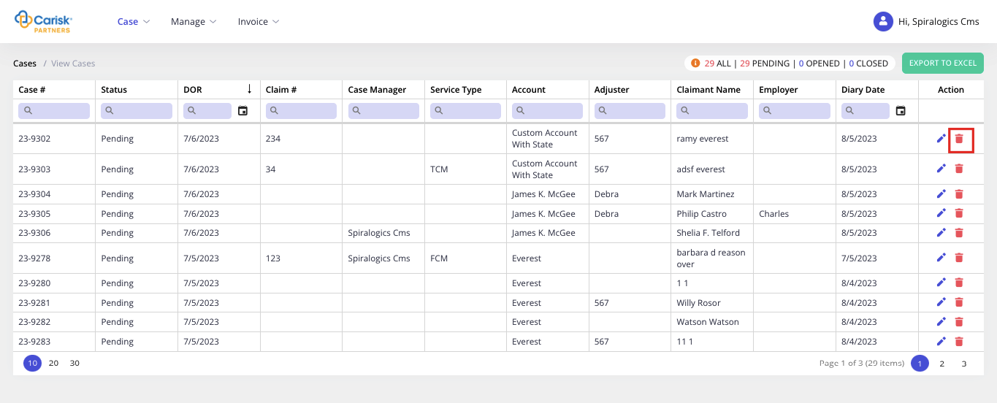
Figure 53: Delete Case
On click, it displays following confirmation dialog box as shown below.
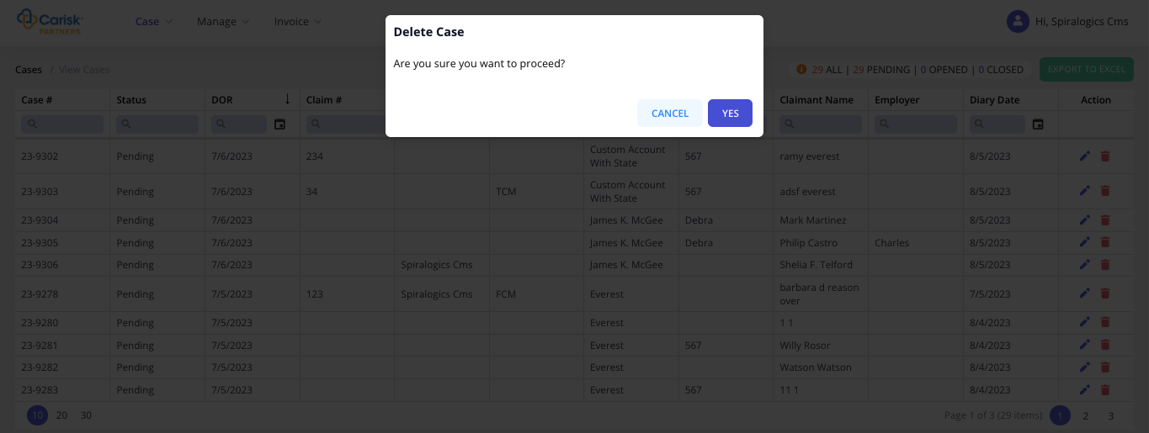
Figure 54: Delete Case Dialog Box
You can click on Yes button to delete the selected case, or click on Cancel button to cancel deletion.

5. Manage
Under the manage menu, you can manage Account and Employee features of the application.
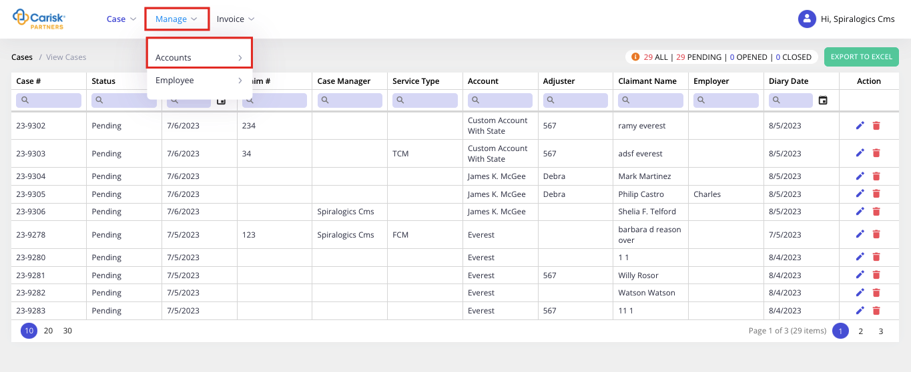
Figure 55: Manage Menu

5.1 Account

5.1.1 Add Account
To add a new account, you can click on Add Account under Accounts as highlighted below:
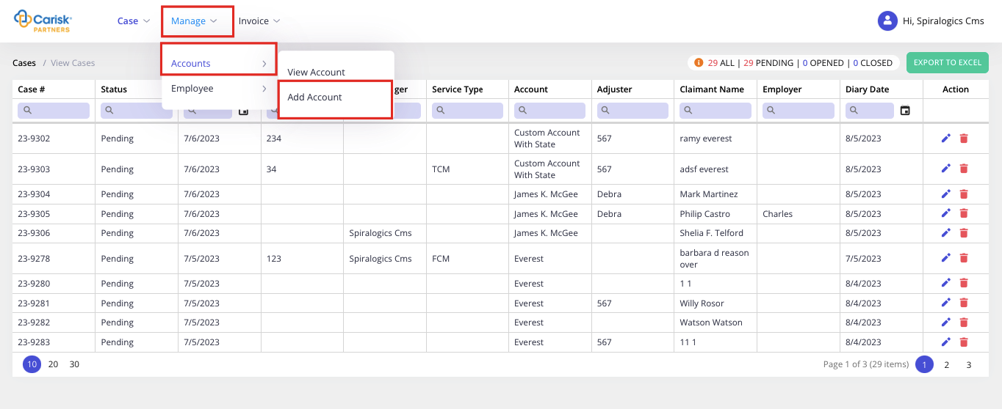
Figure 56: Add Account
When you click, it opens Add Account page as shown below:
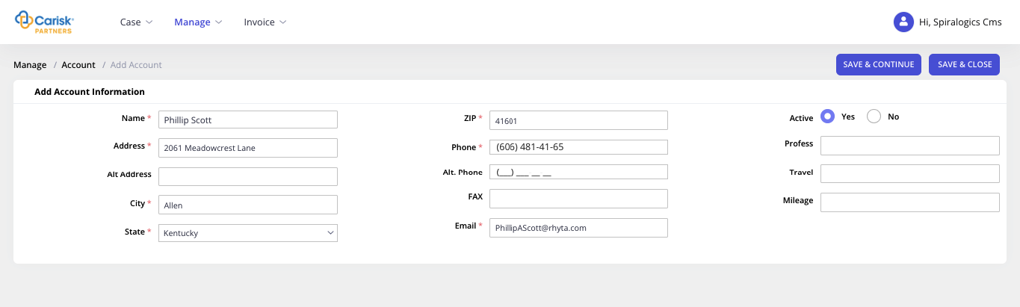
Figure 57: Add Account Info
In this page, following fields are required:
- Name
- City
- State
- Zip
- Phone
- Email
Once all the information is entered, you can click on Save & Continue button which adds a new account and allows you to continue adding further information on the same page.
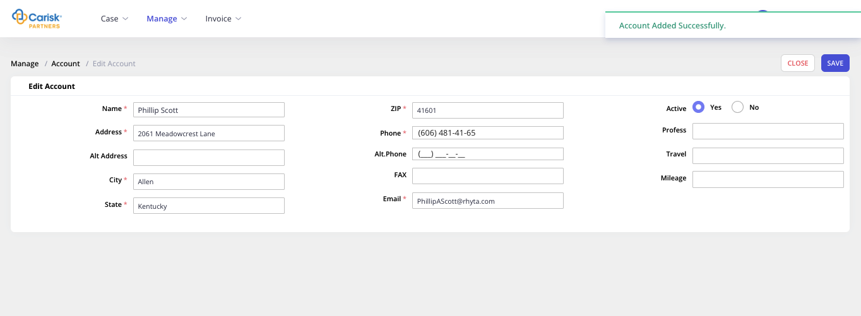
Figure 58: Adding Account
Or, you can click on Save & Close after entering all the required information, which adds a new account and the add page is closed and re-directs to View Accounts page.
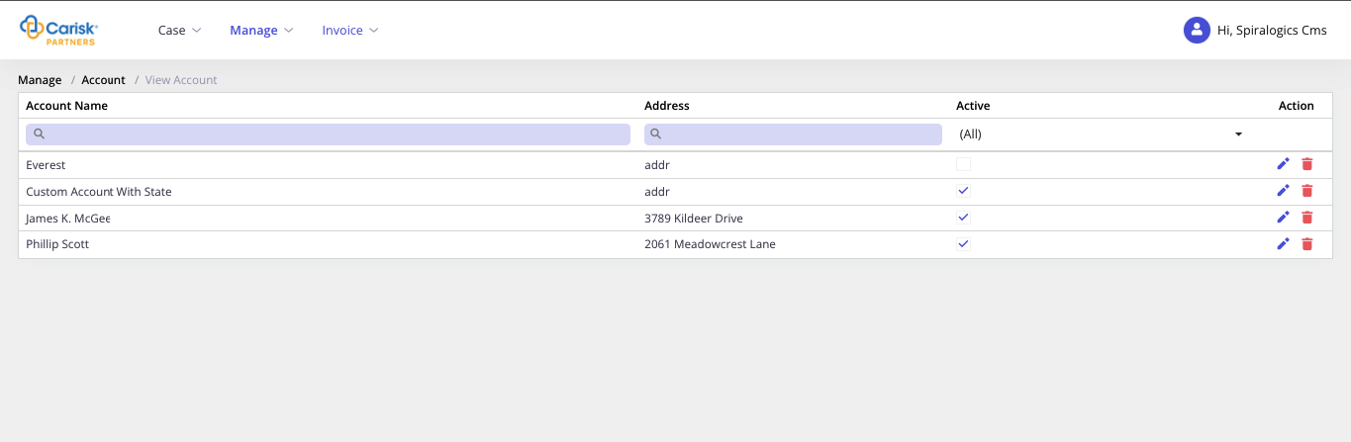
Figure 59: View Account
If all the required fields are not entered, and any one of the save button is clicked then error notification is shown highlighting all the required fields.
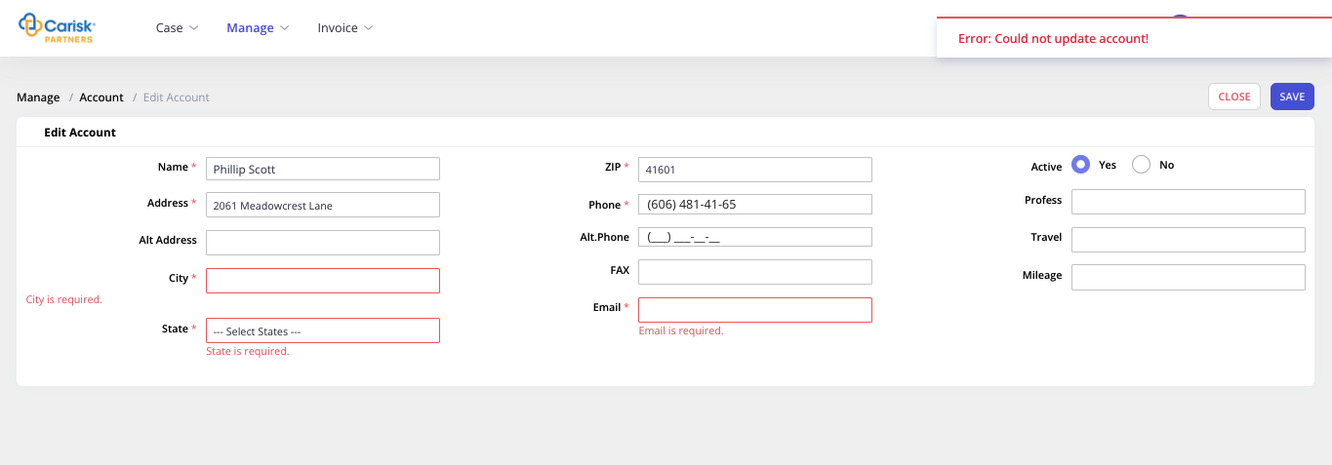
Figure 60: Error in Account Information

5.1.2 View Account
To view the existing list of accounts in the application, you can click on View Account under Accounts as highlighted below:
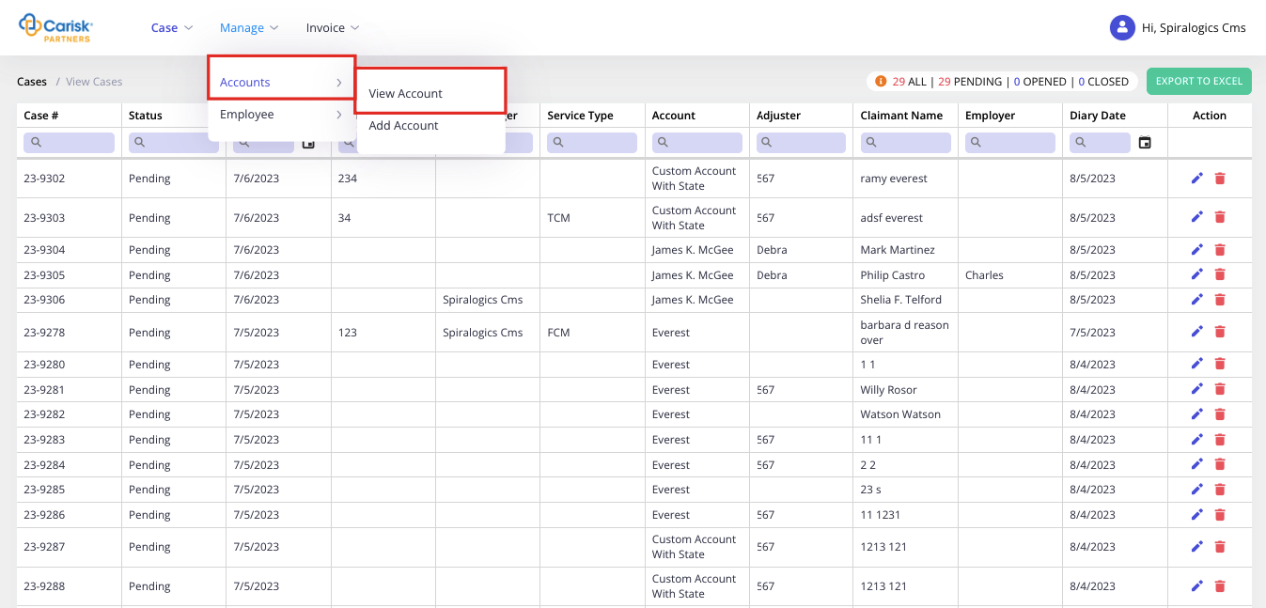
Figure 61: View Account
On click, it opens the following View Account page.
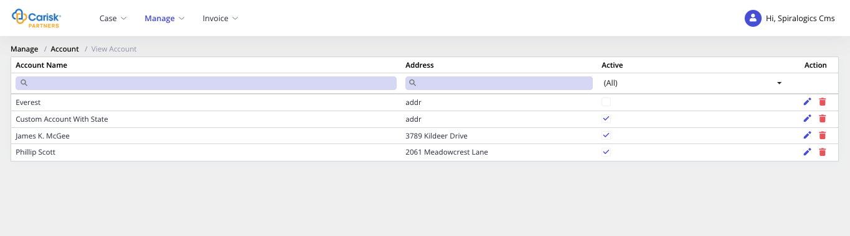
Figure 62: View Account Page
In this view page, you can either edit or delete the account.

5.1.2.1 Edit Account
You can edit your account information, by clicking on Edit button as highlighted below in action column of the required row of account.
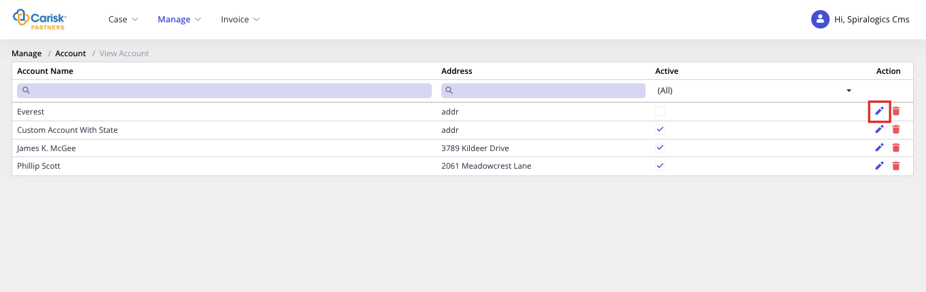
Figure 63: Edit Account
On click, it opens the Edit Account page as shown below:
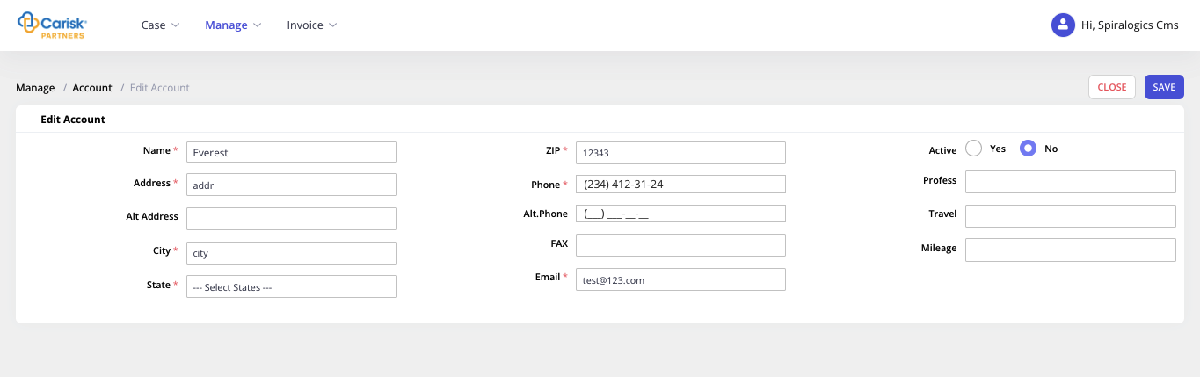
Figure 64: Account Page
You can edit the account information and click on Save button to update account details.

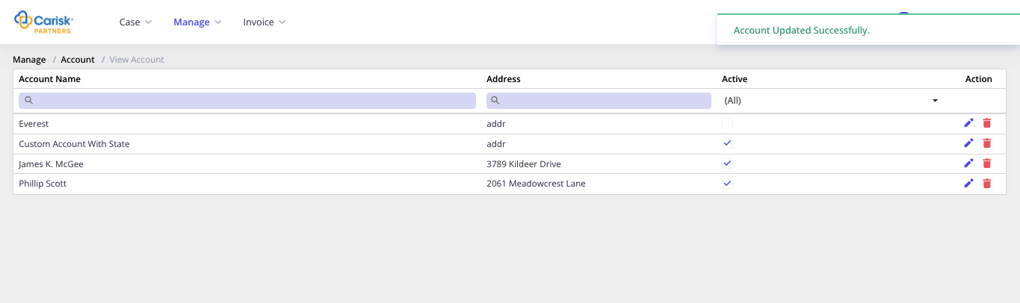
Figure 65: Account updated successfully

5.1.2.2 Delete Account
To delete case, you can click on Delete button as highlighted below in action column of required row of account.
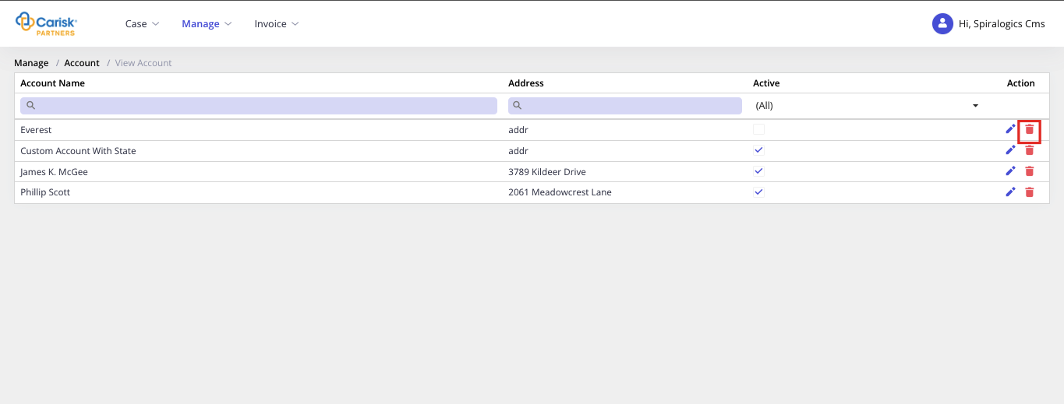
Figure 66: Delete Account Button
On click, it displays following confirmation dialog box as shown below.
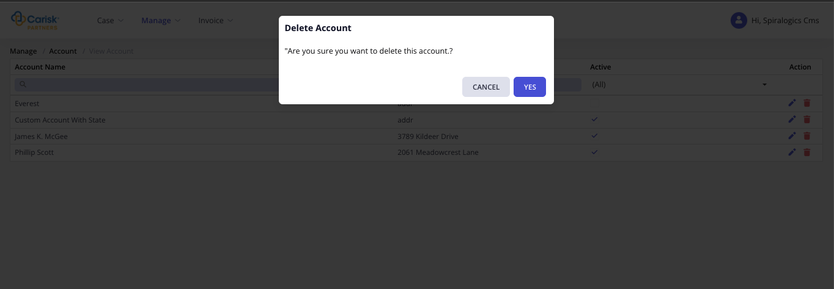
Figure 67: Delete Account
You can click on Yes button to delete the selected case, or click on Cancel button to cancel deletion.
Note: You can’t delete an account when it is linked to any existing case.

5.2 Employee
Information of employees who are using the application is added here.

5.2.1 Add Employee
To add a new employee, you can click on Add Employee under Employee as highlighted below:
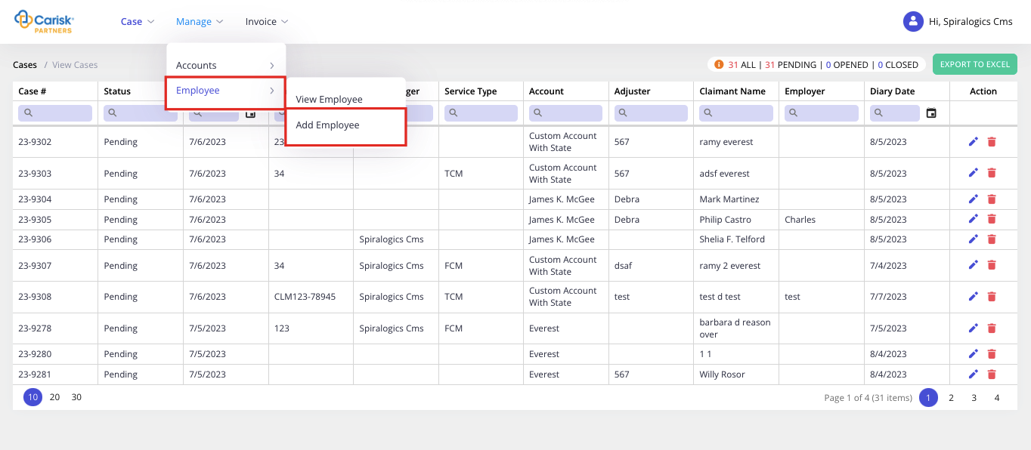
Figure 68: Adding Employee
When you click, it opens Add Employee page as shown below:
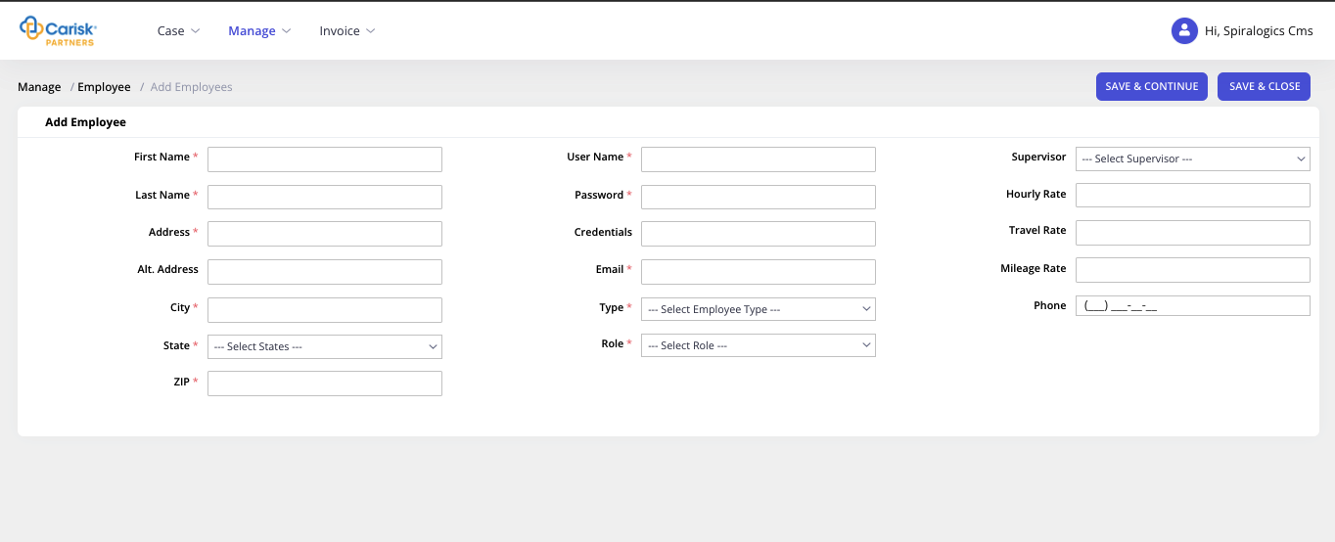
Figure 69: Add Employee Page
In this page, following fields are required:
- First Name
- Last Name
- User Name
- Password
- Address
- Email
- City
- State
- ZIP
- Role
Once all the information is entered, you can click on ‘Save & Continue’ button which adds a new employee and allows you to continue adding further information on the same page.
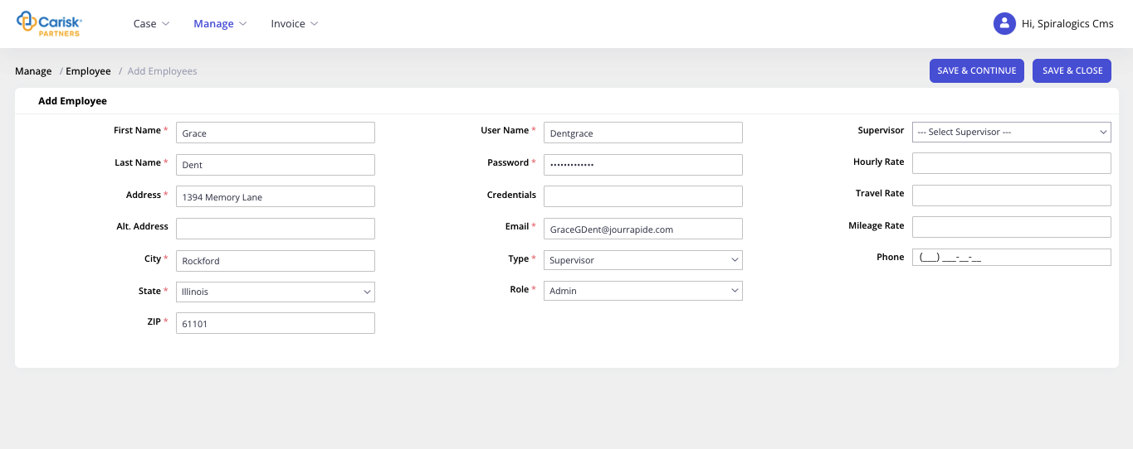
Figure 70: Employee Added Successfully
Or, you can click on Save & Close after entering all the required information, which adds a new employee and the add page is closed and re-directs to View Employee page.
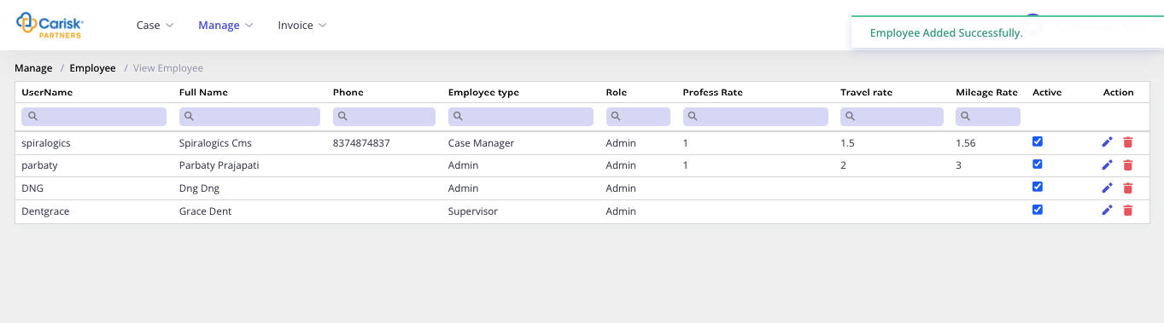
Figure 71: View Employee
If all the required fields are not entered, and any one of the save button is clicked then error notification is shown highlighting all the required fields.
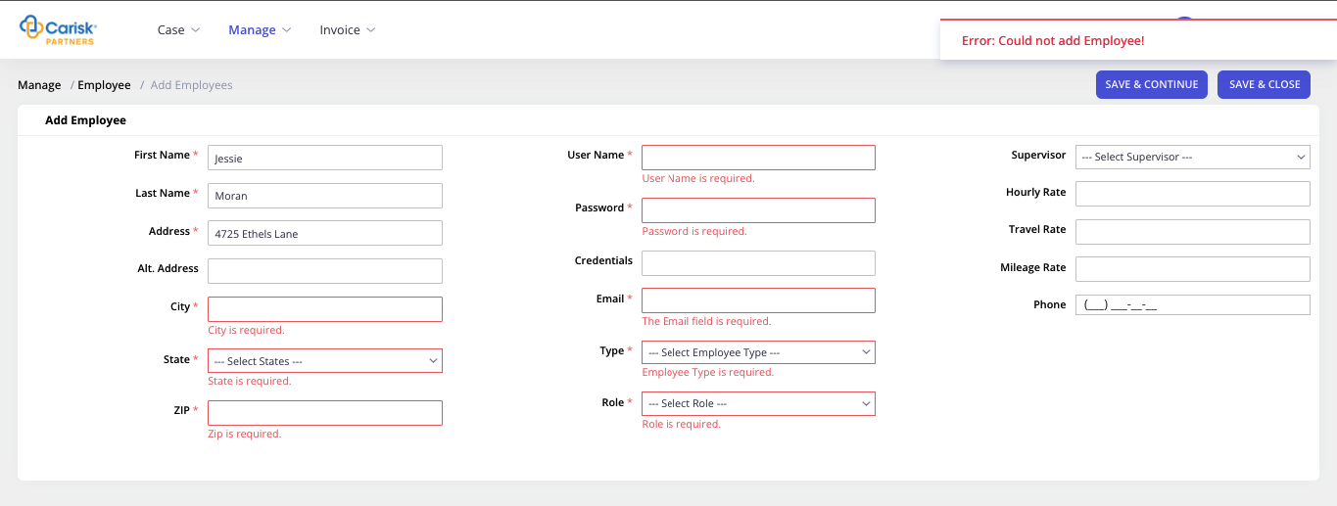
Figure 72: Error while adding employee

5.2.2 View Employee
To view the existing list of employees in the application, you can click on View Employee under Employee menu as highlighted below:
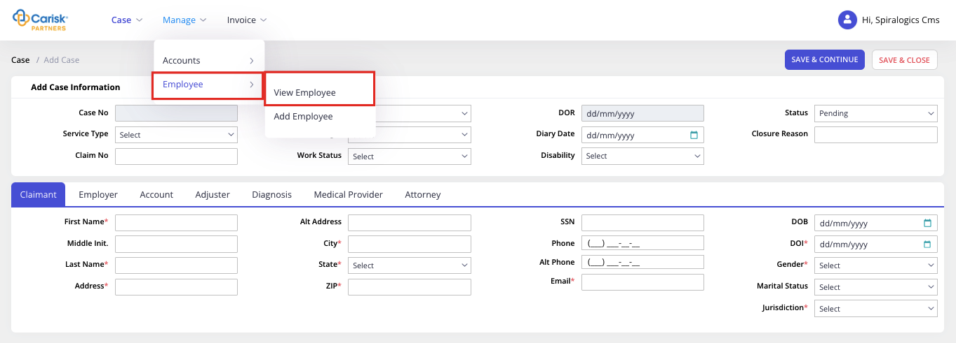
Figure 73: View Employee Tab
On click, it opens the following View Employee page.
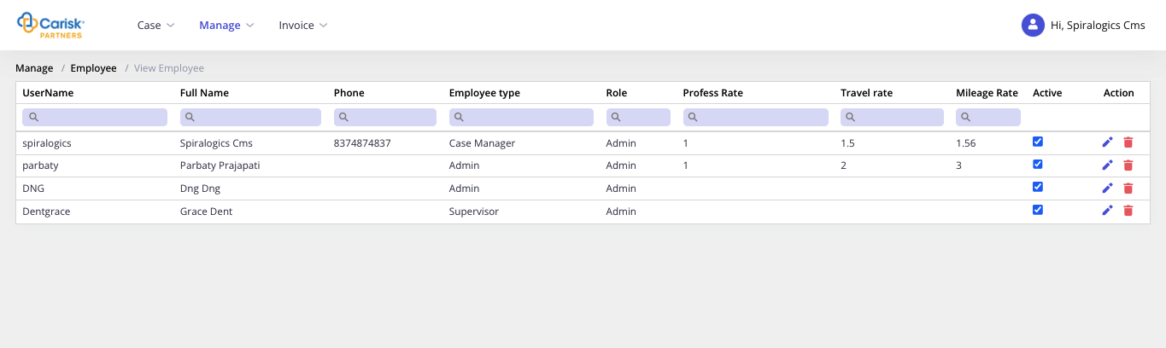
Figure 74: View Employee Page
In this view page, you can either edit or delete the Employee.

5.2.2.1 Edit Employee
You can edit employee details, by clicking on Edit button as highlighted below in the action column of required row of employee.
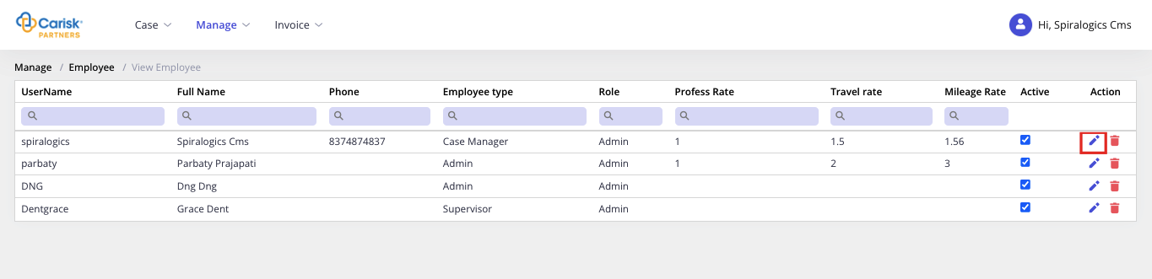
Figure 75: Edit Employee
On click, it opens the Edit Employee page as shown below:
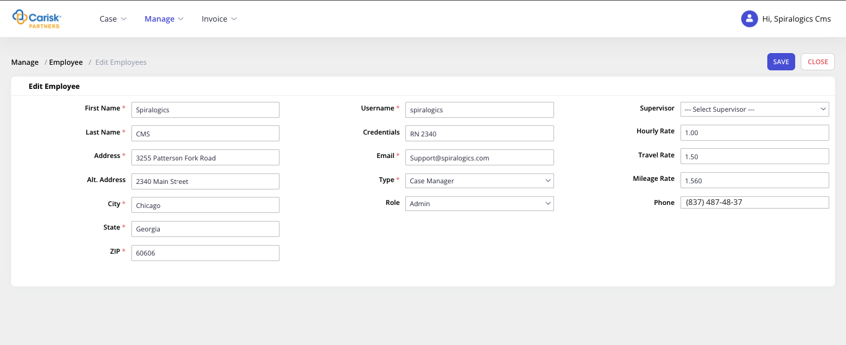
Figure 76: Edit Employee fields
You can edit the employee information and click on Save button to update employee details.
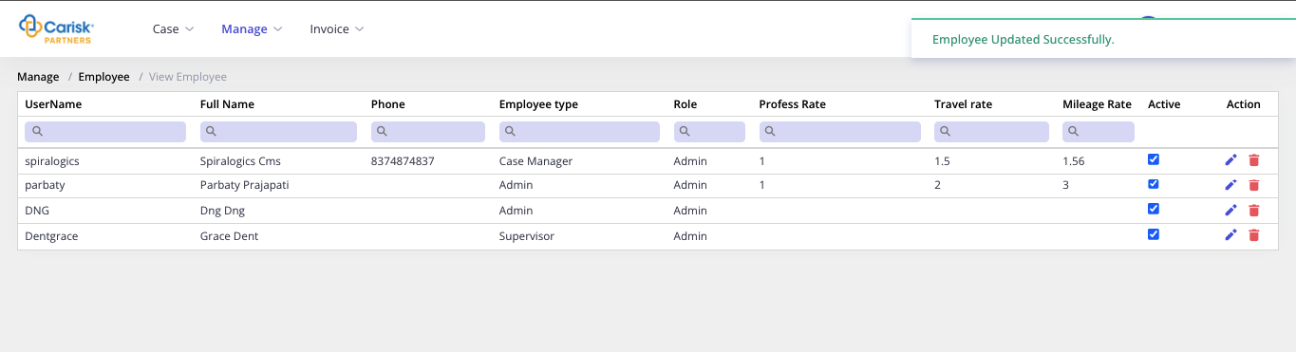
Figure 77: Save & Continue Employee

5.2.2.2 Delete Employee
To delete employee, you can click on Delete button as highlighted below in action column of required row of Employee.
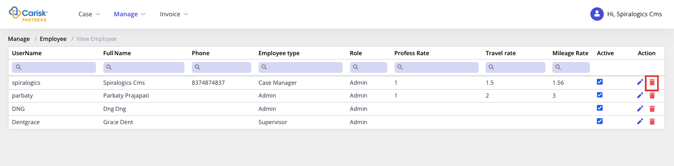
Figure 78: Delete Employee
On click, it displays following confirmation dialog box as shown below.
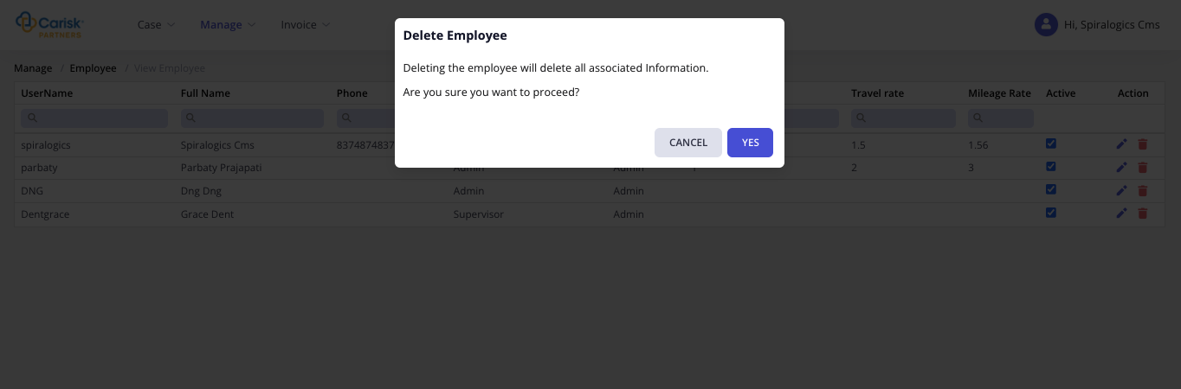
Figure 79: Delete Employee
You can click on Yes button to delete the selected employee, or click on Cancel button to cancel deletion.

6. Invoice
Generated invoices which are pending or approved are listed in this module under respective menu.

6.1 Pending Invoice
You can click on Pending Invoices under Invoices menu as highlighted below:
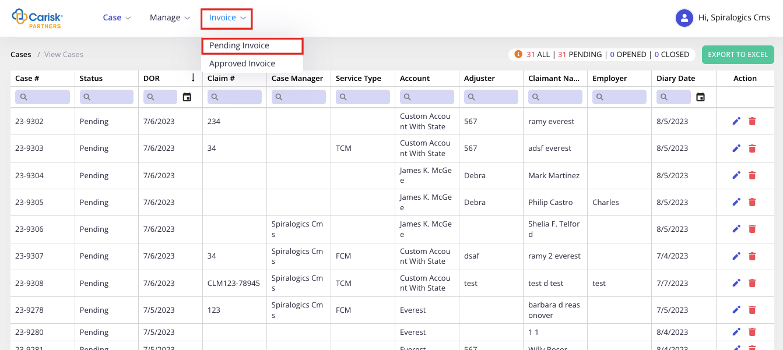
Figure 80: Pending Invoice
On click, it opens the Pending Invoices page as shown below.
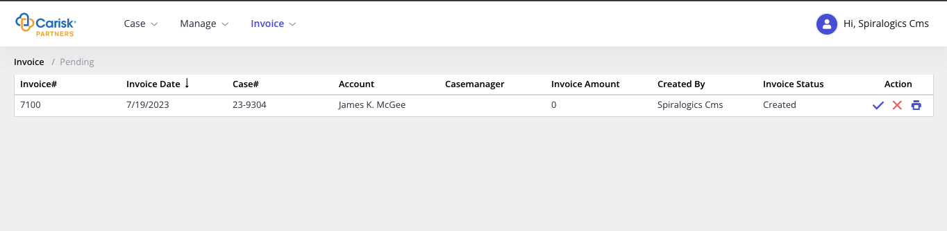
Figure 81: Pending Invoices
In this page, you can either approve or reject invoice as well as print them.

6.1.1 Approve Invoices
To approve invoice, you can click on tick sign under action column as highlighted below.
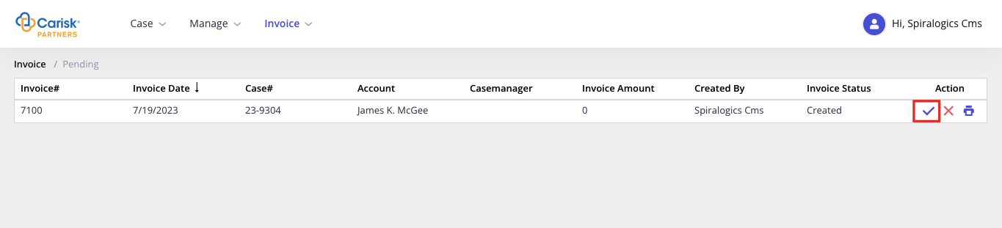
Figure 82: Approve Invoices
Once the invoice is approved it is listed under Approved Invoices.

6.1.2 Reject Invoices
To reject invoice, you can click on cross sign under action column as highlighted below.
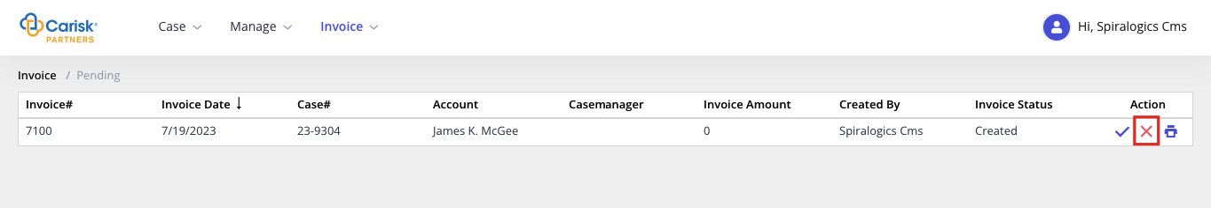
Figure 83: Reject Invoices
Once the invoice is rejected, you will get a notification and rejected invoice will be listed under Activity tab which can be further edited.
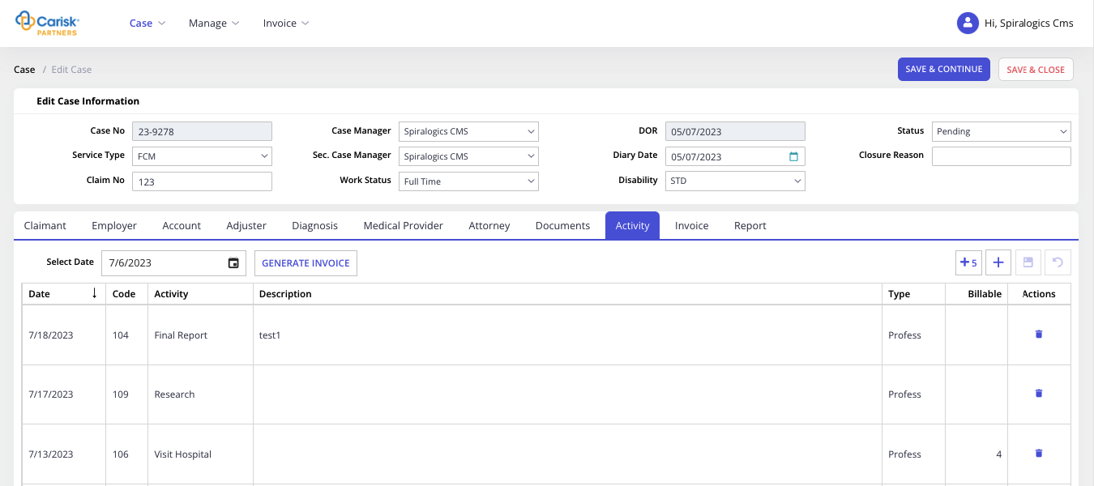
Figure 84: Rejected Invoices under Activity Tab

6.2 Approved Invoices
You can click on Approved Invoices under Invoices menu to view invoices that have been approved.
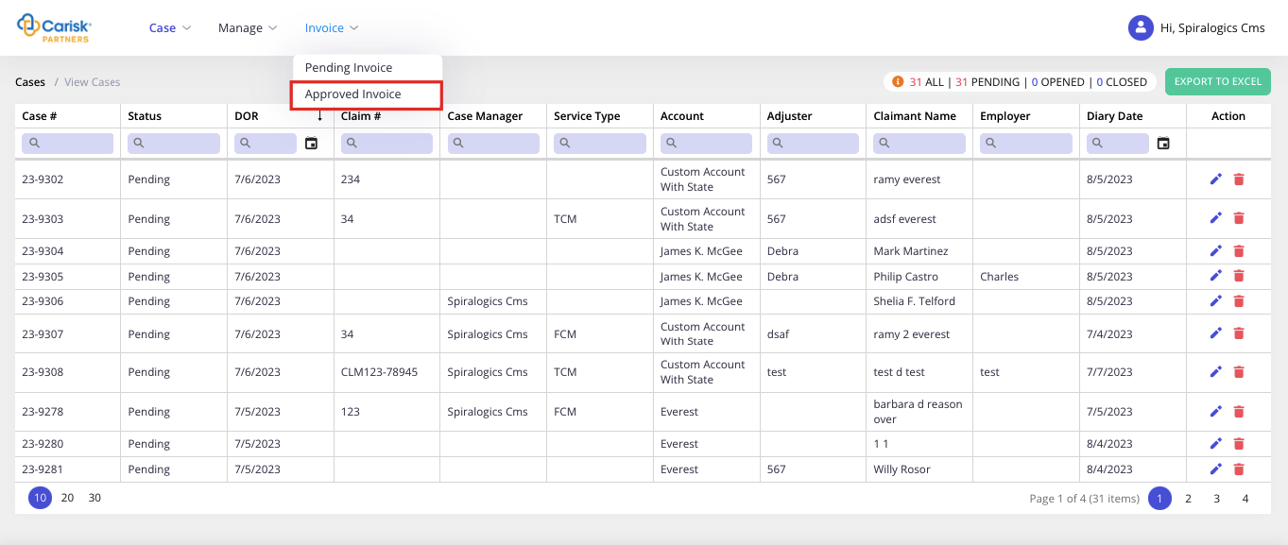
Figure 85: Approved Invoices
On click, it opens the Approved Invoices page as shown below.
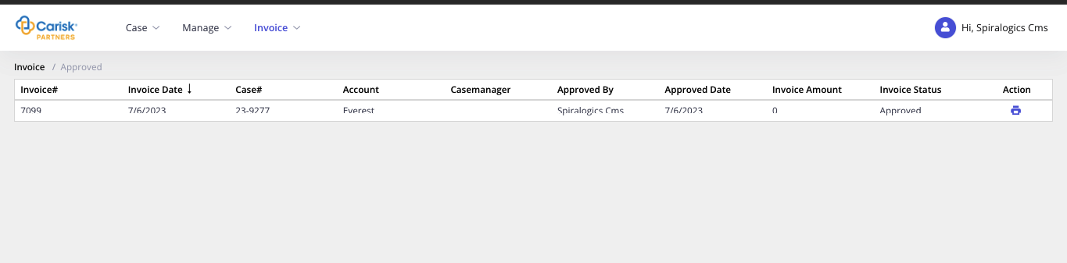
Figure 86: Approved Invoices Page
In this page, you can print the approved invoices by clicking print icon under action column.
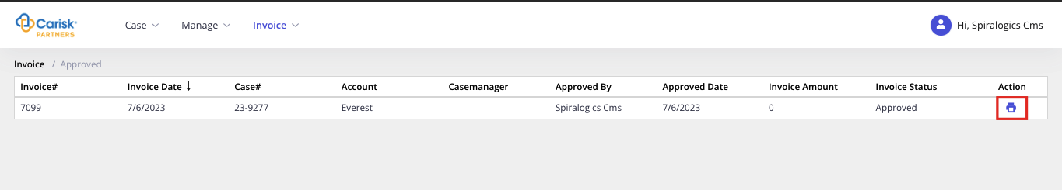
Figure 87: Print Approved Invoices
On click, it opens the following popup where you can PRINT to print invoice or CLEAR button to cancel print operation.

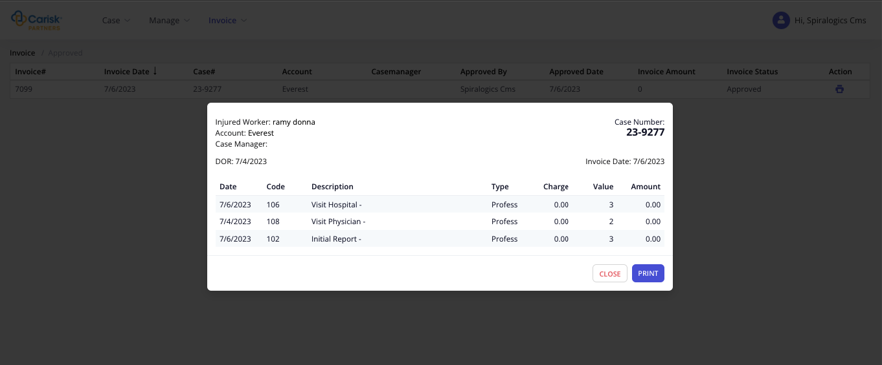
Figure 88: Print Invoice Popup

7. Sign Out
You can sign out from the application by clicking on Sign Out button under the profile section.
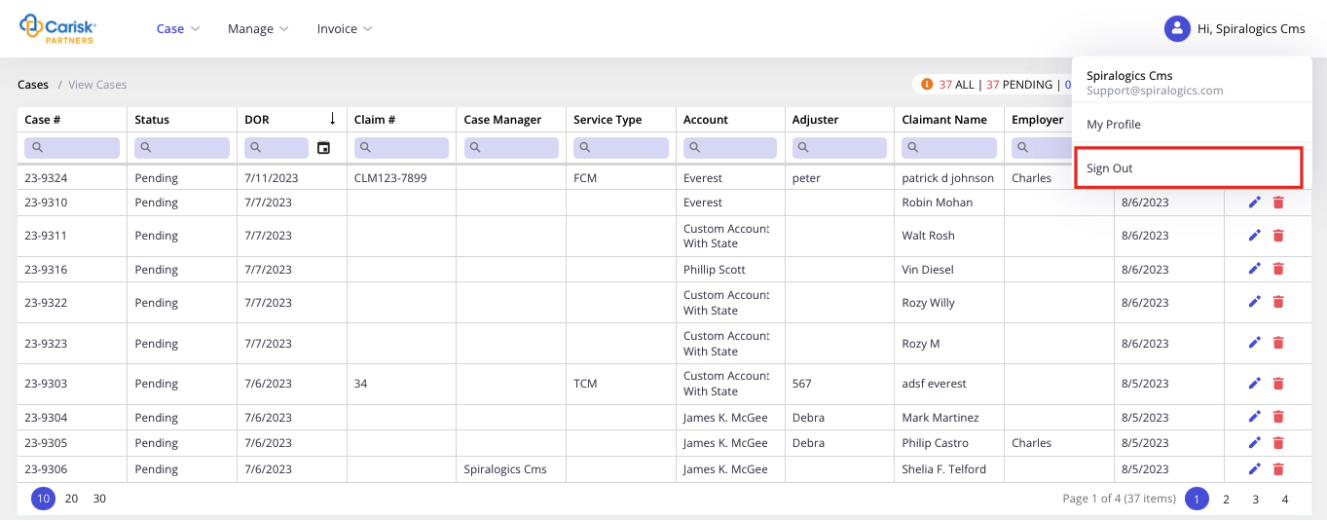
Figure 91: Sign Out
On click, it renders following confirmation dialog box.
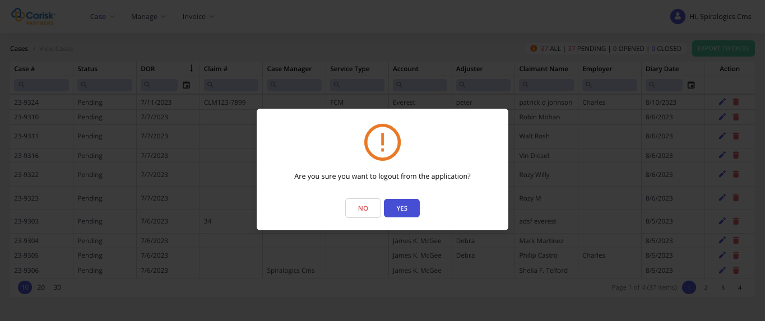
Figure 92: Log Out from Page
Click on YES to logout of the application and click on NO to stay logged in.

